**Assignment-1**

**Create a Graph displaying category & subcategory wise sales**

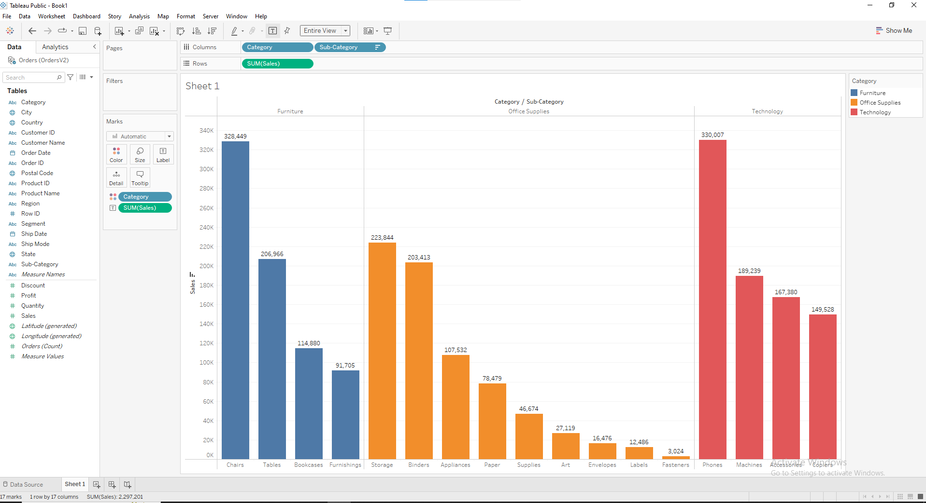

**Assignment-2**

**Category, Region & Sub-Category wise Profit**

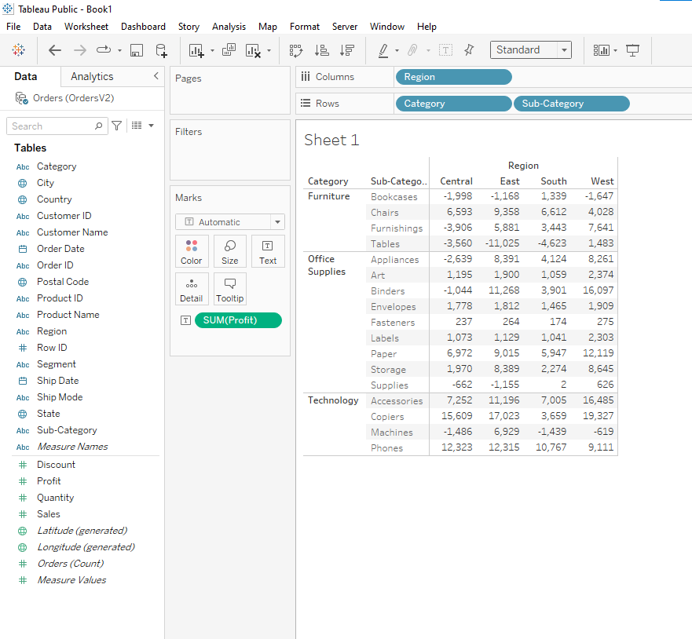

**Assignment-3**

**Display year wise Sales, Discount, Profit & Quantity using Measures Names**

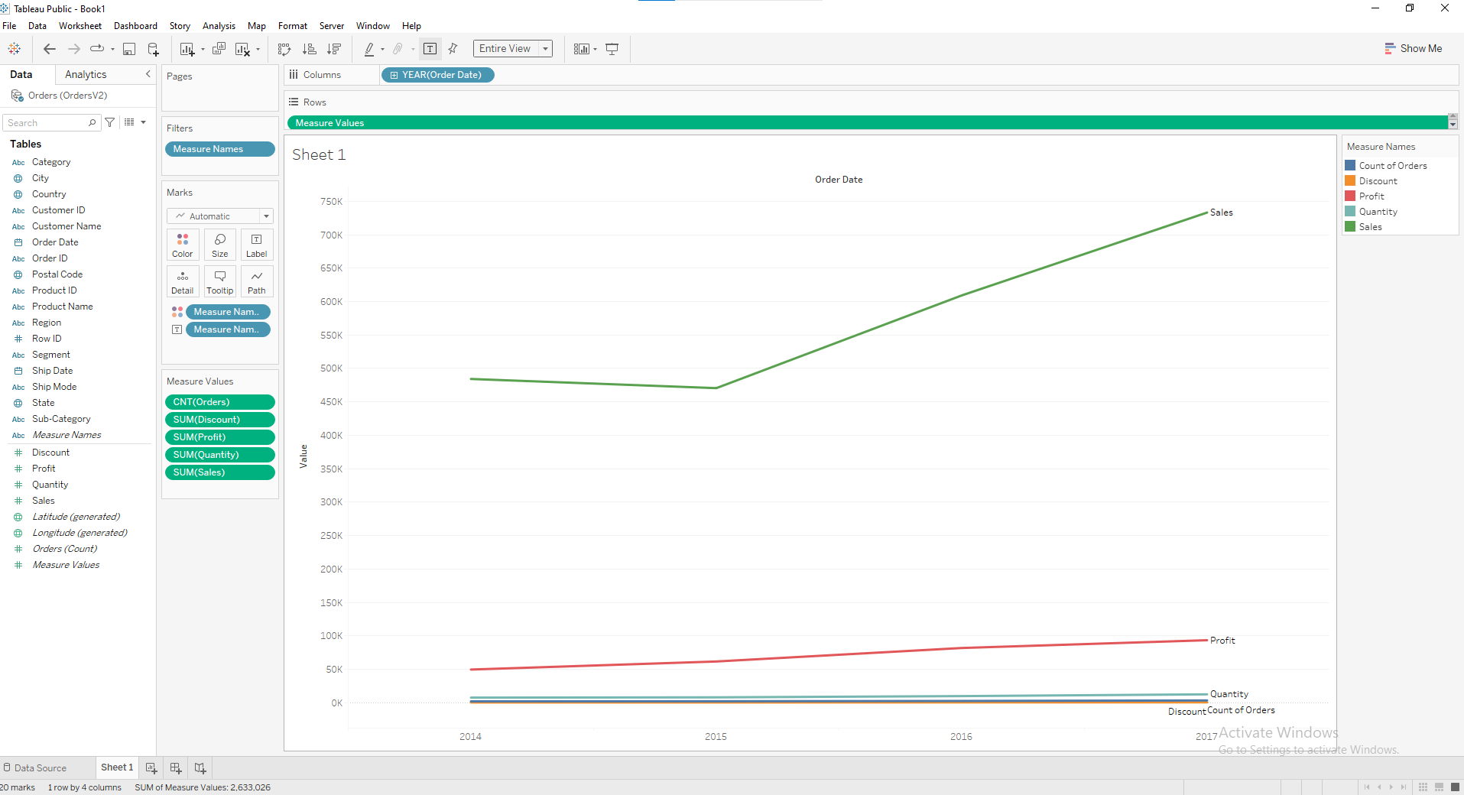

**Assignment-4**

**Display Sales using Hierarchy for Region, Segment, Category, Subcategory**

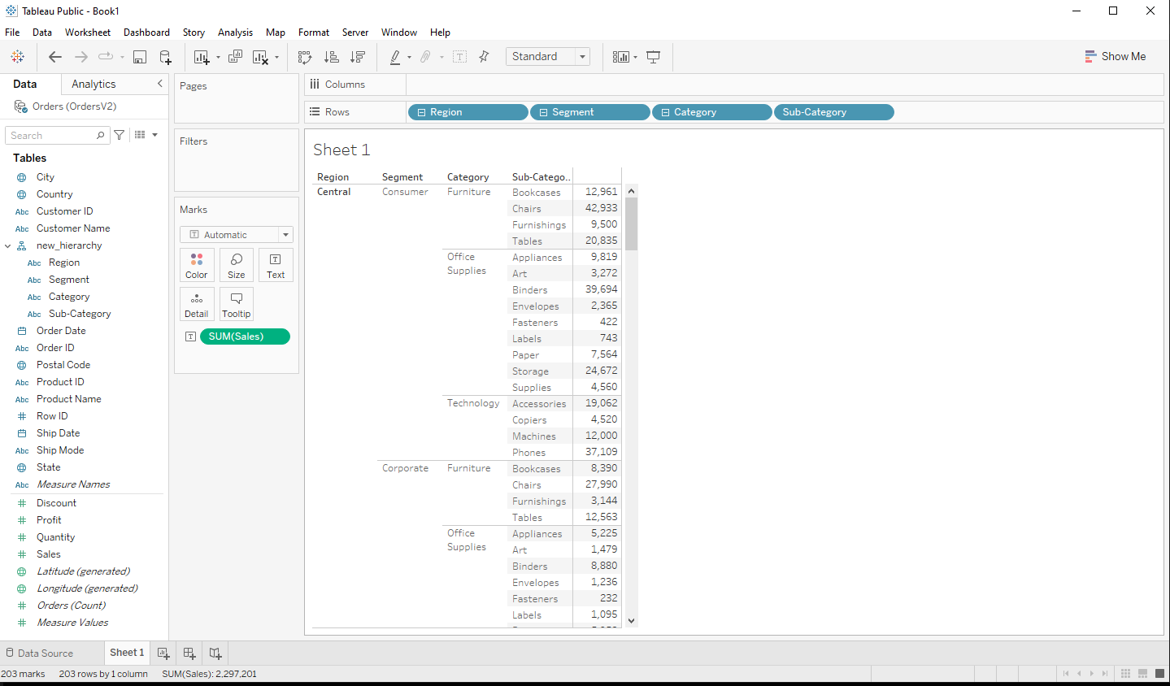

**Assignment-5**

**Create a horizontal Bar chart to represent subcategory sales, all stationary related subcategories like paper, label etc should be grouped as Stationary.**

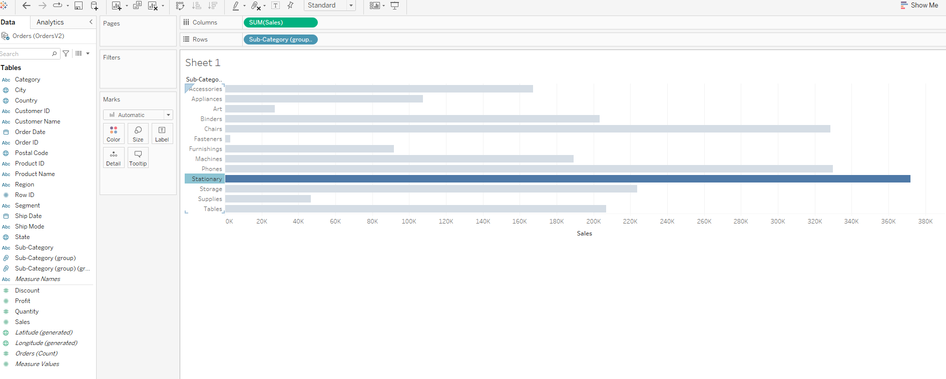

**Assignment-6**

**Represent Subcategory wise profit in graphical manner, arranged in the descending order of profit**.

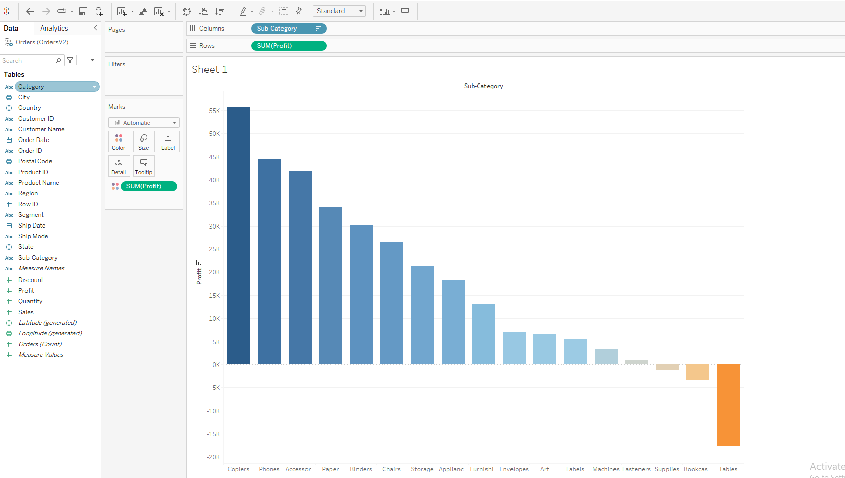

**Class 2 assignments 1st assignment**

**Interactive Graph to highlight top 5 Profit generating categories –(Use Parameter)**

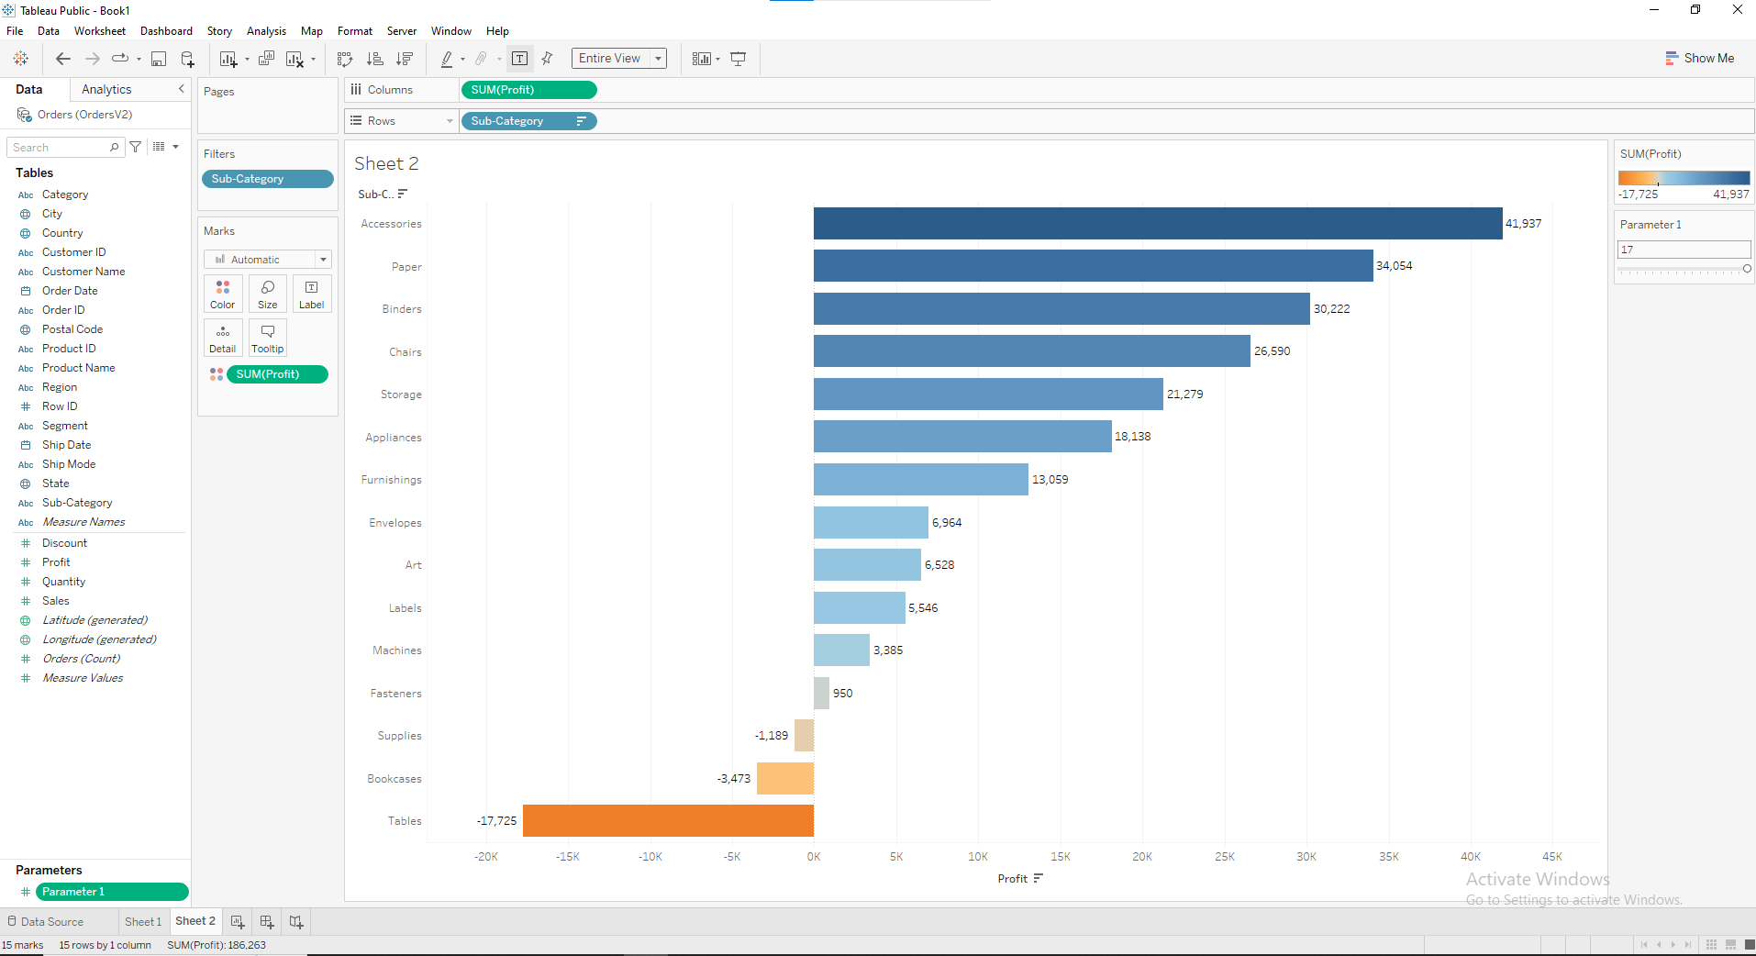

**2nd assignment**

**Interactive category & subcategory wise sales - (using sets)**

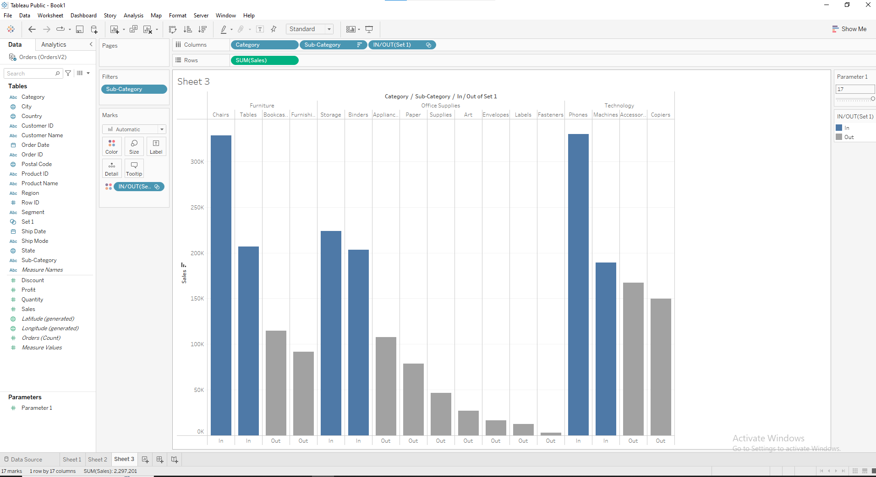

**3rd assignment**

**YEAR wise segment wise sales**

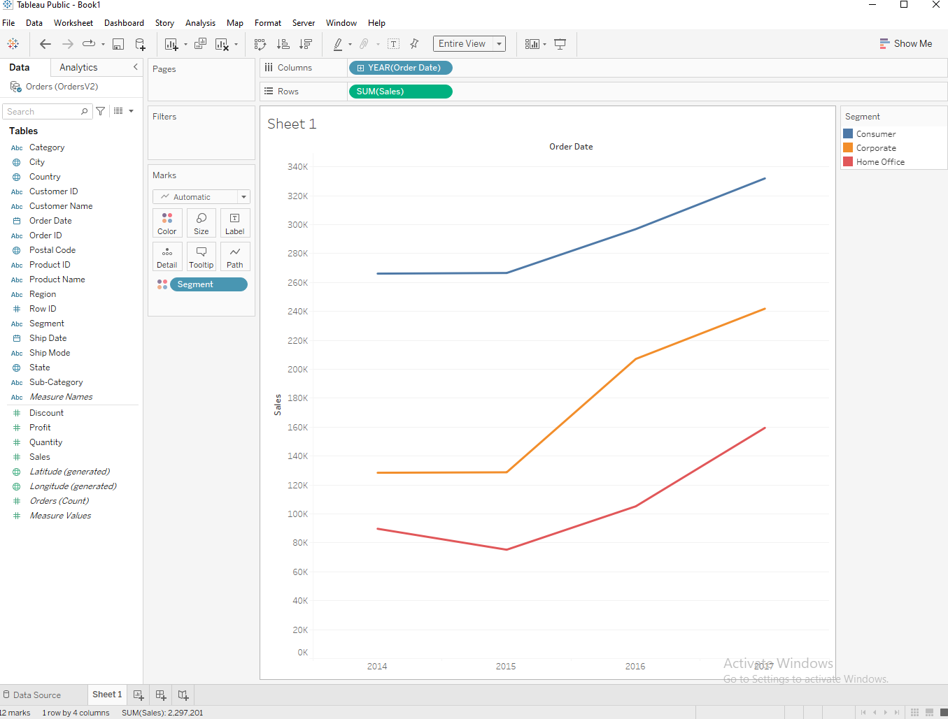

**4th assignment**

**Display Sales based on Region, Category, Subcategory. Should be Interactive on Region with Dynamic Title & Caption.**

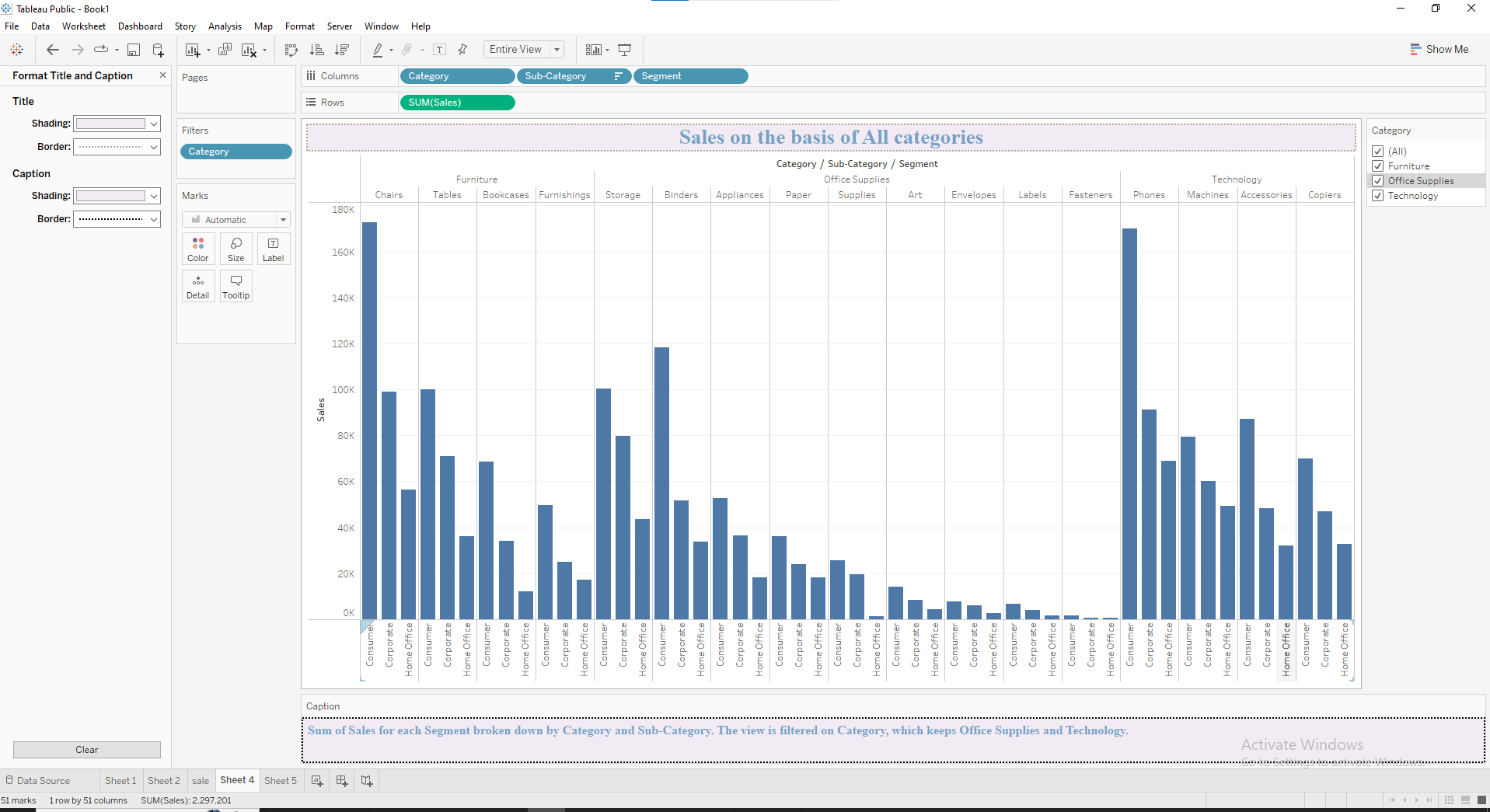

**5th assignment**

**All the fields related to customer should be in the Customer folder & product related fields in Products folder**

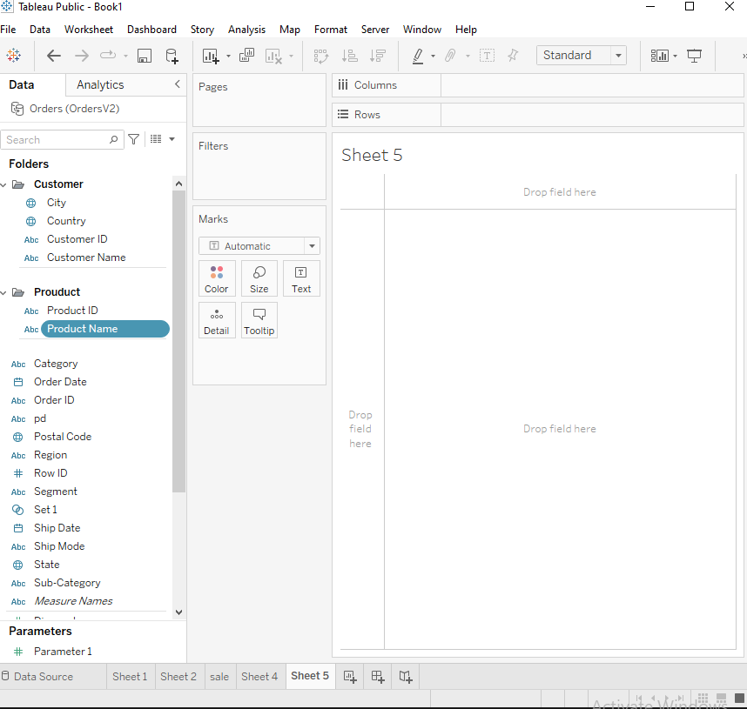

6th assignment

Segment wise monthly cost on the basis of shipping date

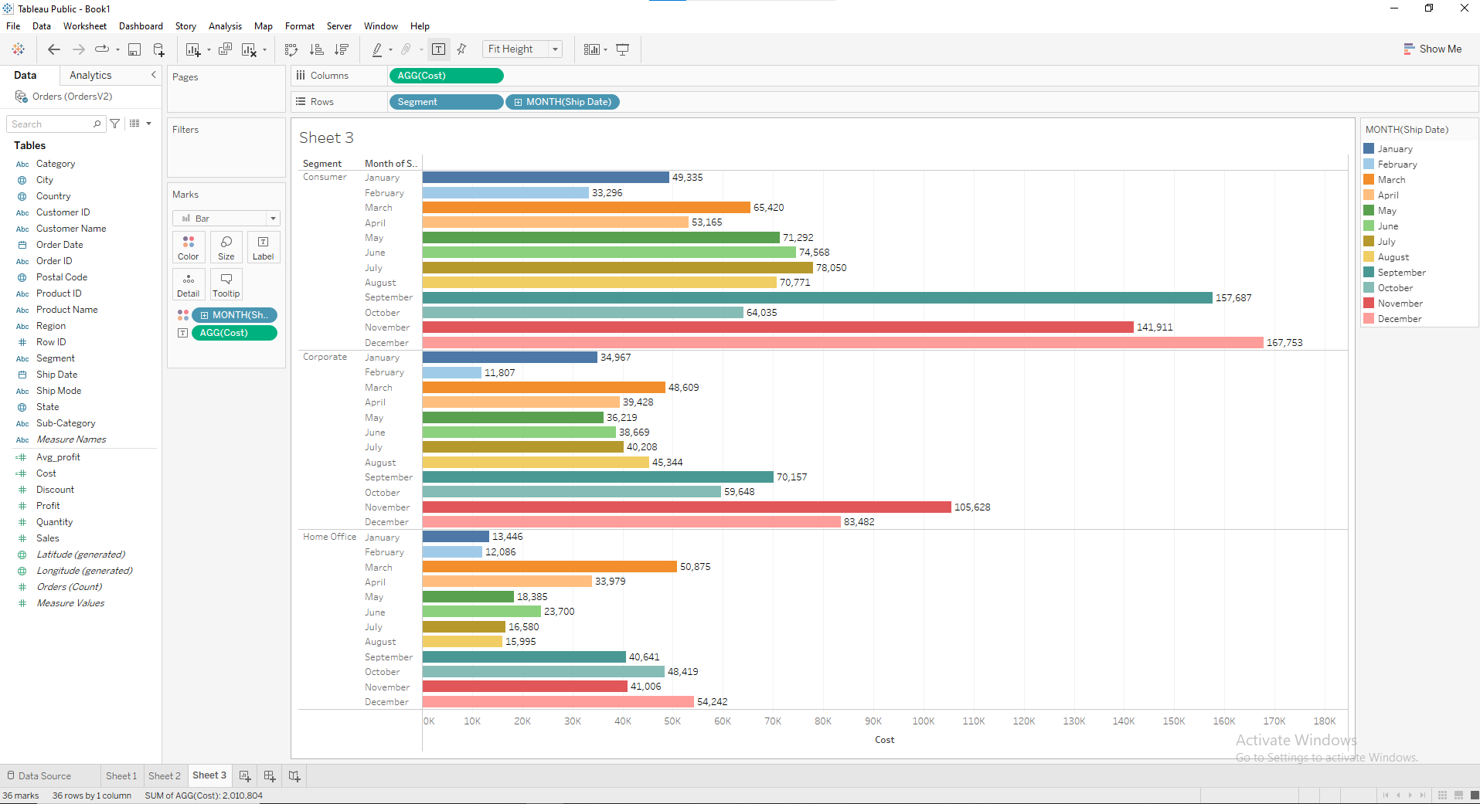

**7th assignment**

**Display sales value using a combined field for Region, Segment Category**

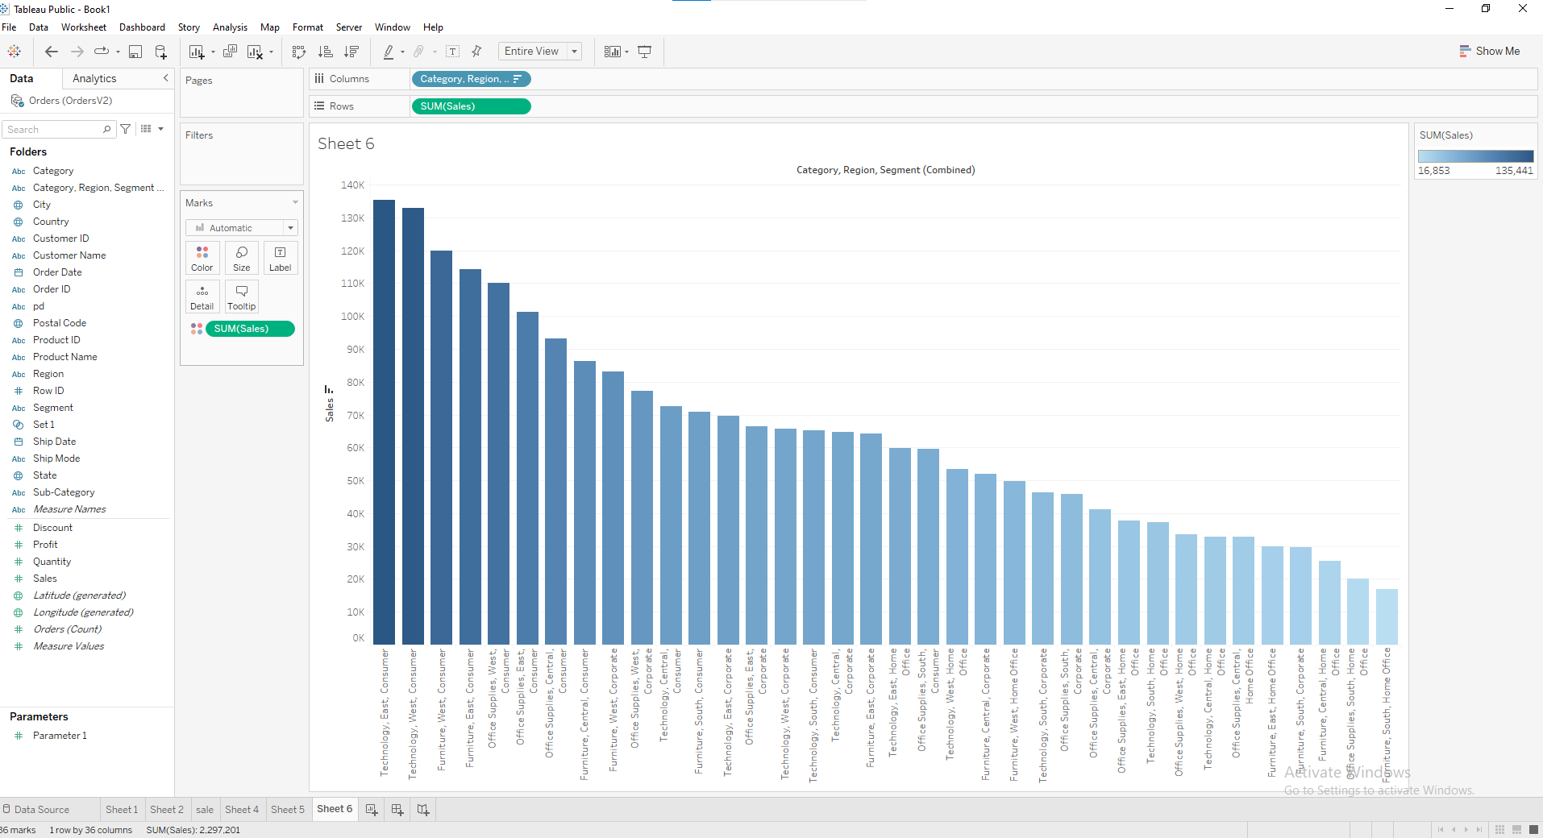

**8th assignment**

**Use Inner Join to join electronic & books data source and in the Tabular format display electric, book & total sales on the basis of Region & State**

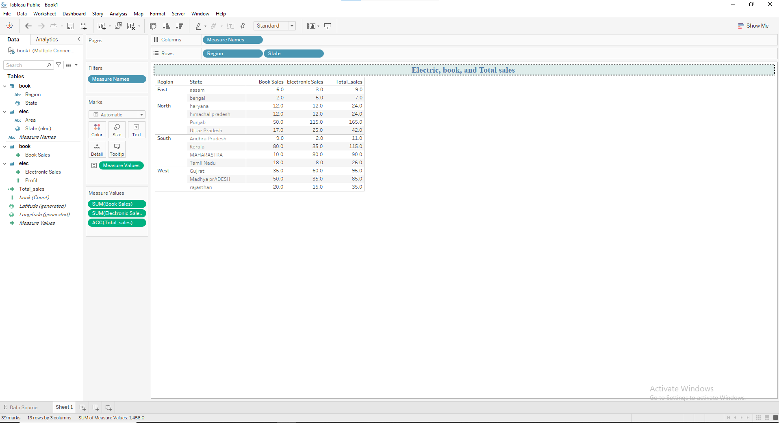

**9th assignment**

**Use Full Join to join electronic & books sheets and create a line graph to display Area wise Electronic,Book & Total sales in same plot area**

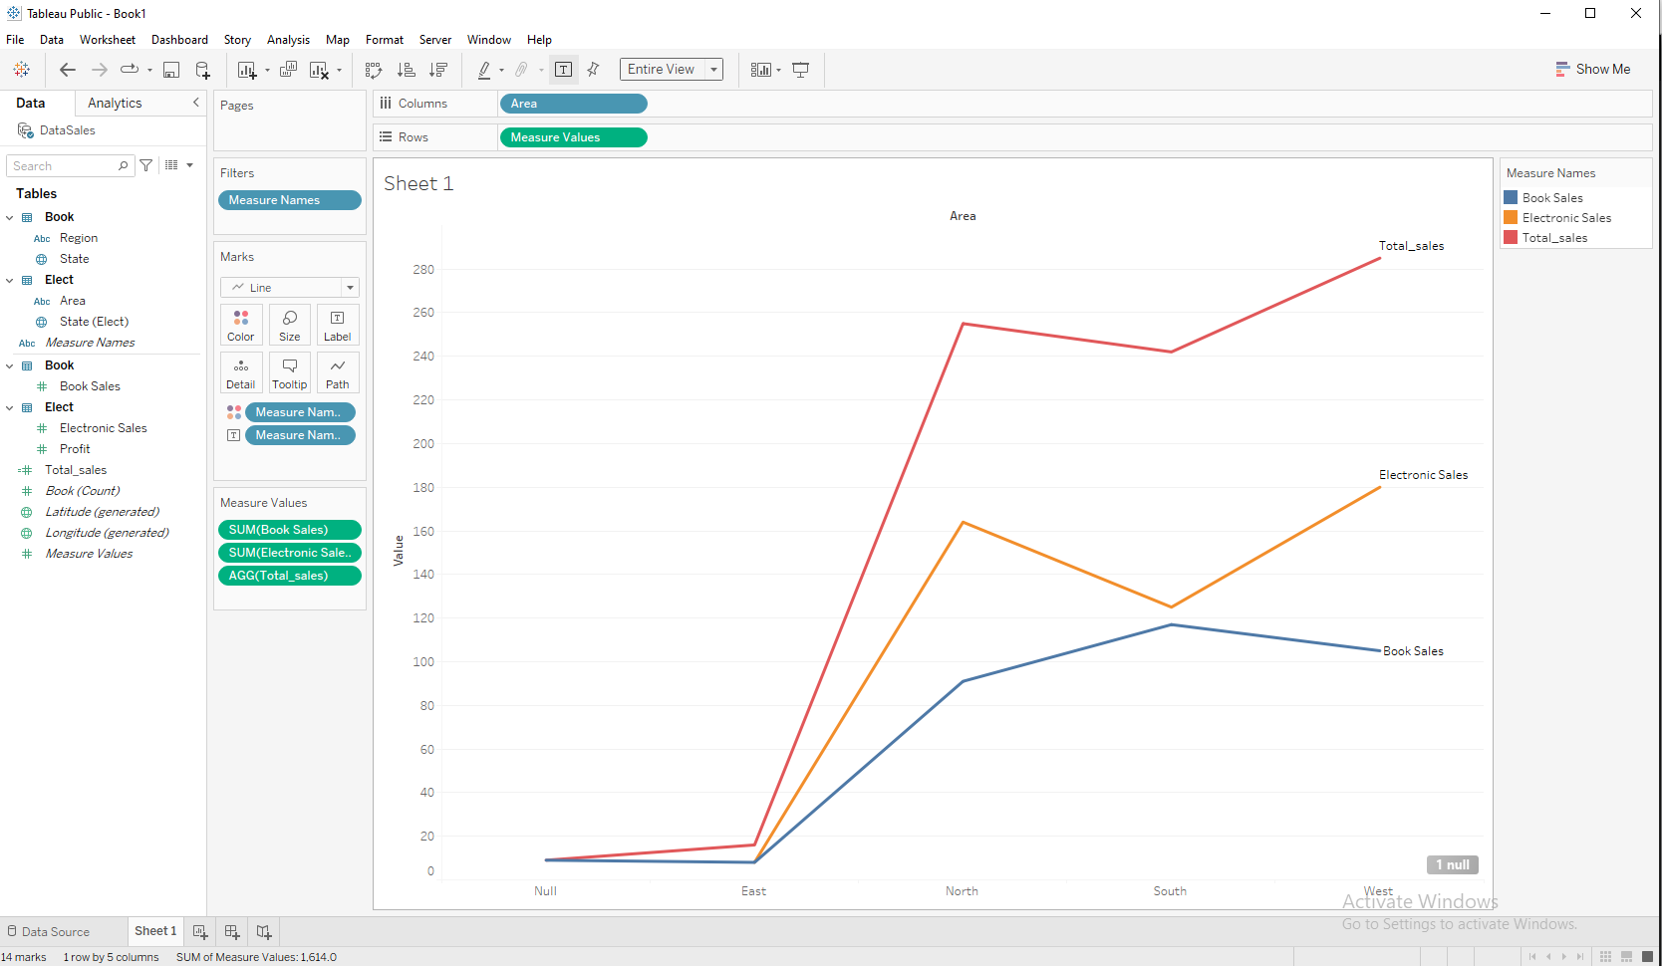

**10th assignment**

**Blend the data from electronic & books data source and display Electronic ,Book & Total sales on the basis of state.**

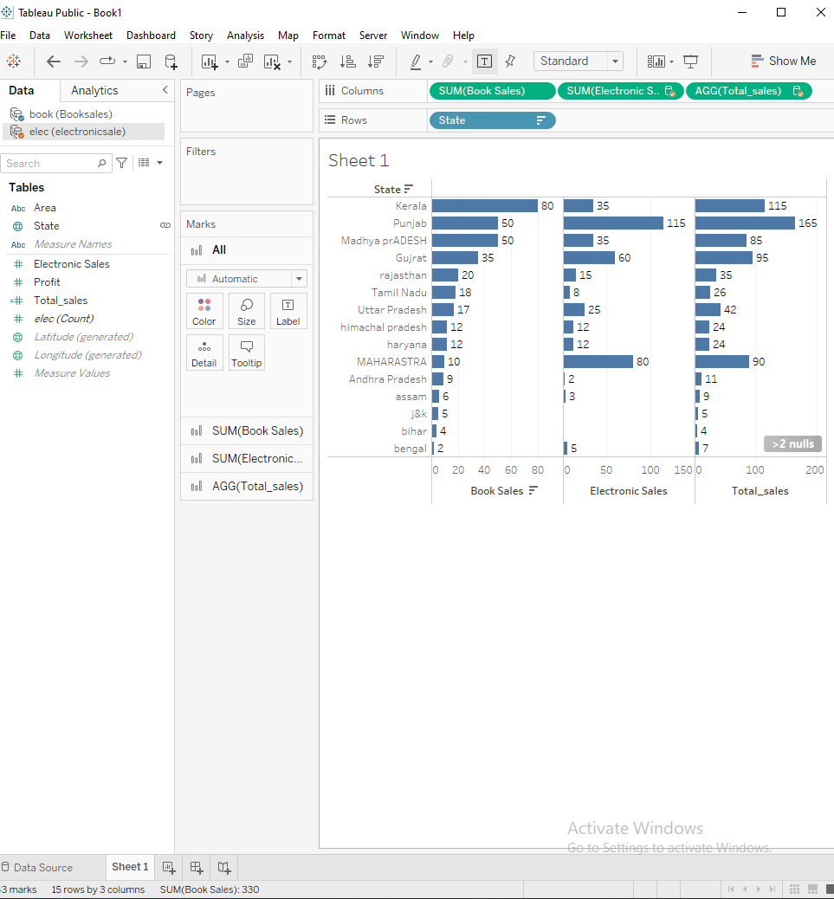

**11th assignment**

**Create a Bar chart to display the top 10 profit-making subcategories along with the categories**

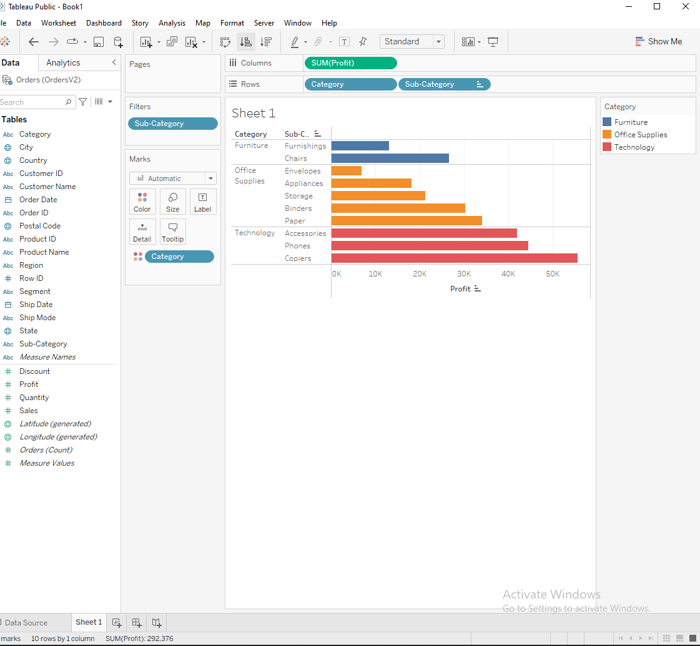

**12th assignment**

**Chart to display only those subcategories & categories where the revenue is 200K to 250K.**

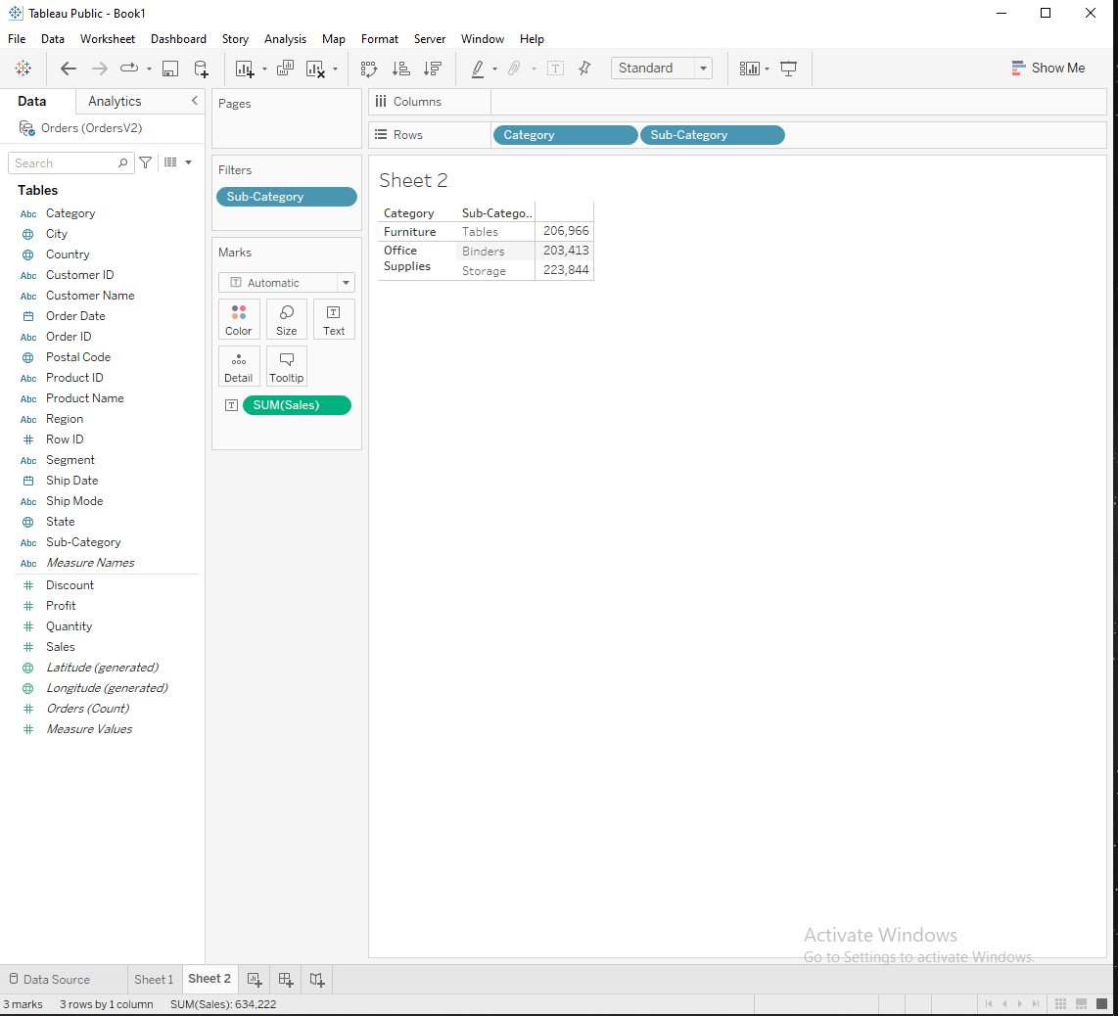

**13th assignment**

**Display month wise profit of each category . Should be interactive on the basis of year. Use a slider as filter**

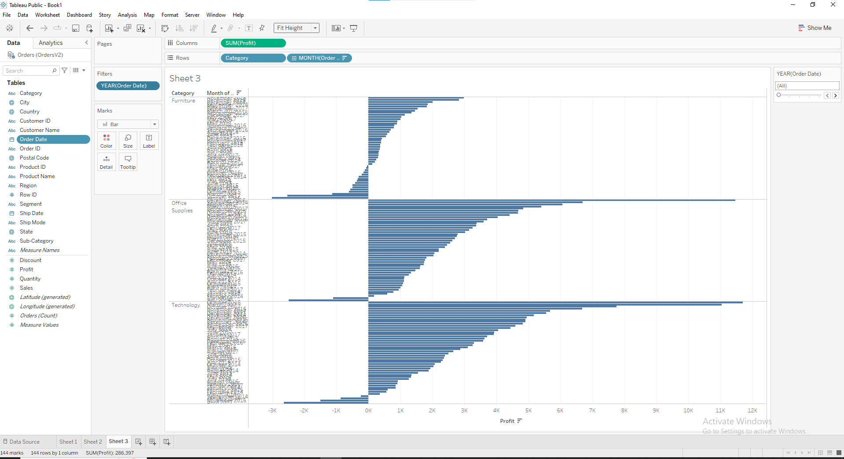

**14th assignment**

**Create a bar chart to represent category & subcategory wise sales, where the revenue is more than 200K and profit is more than 20K**

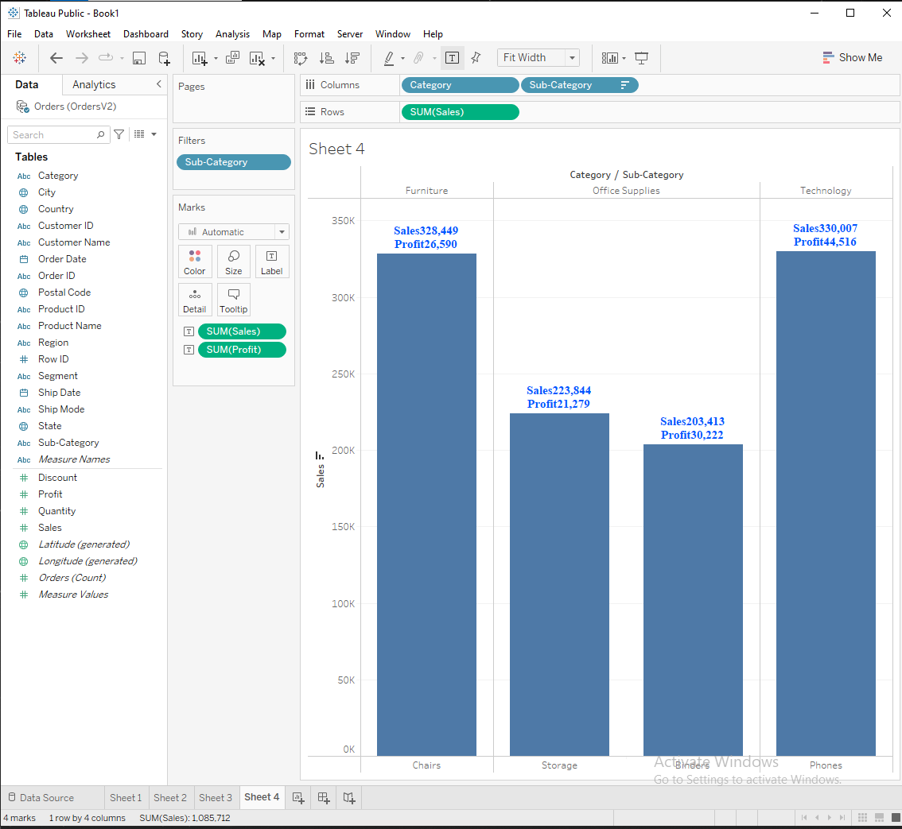

**15th assignment**

**Using the data source filter update all the above charts only for the Technology category.**

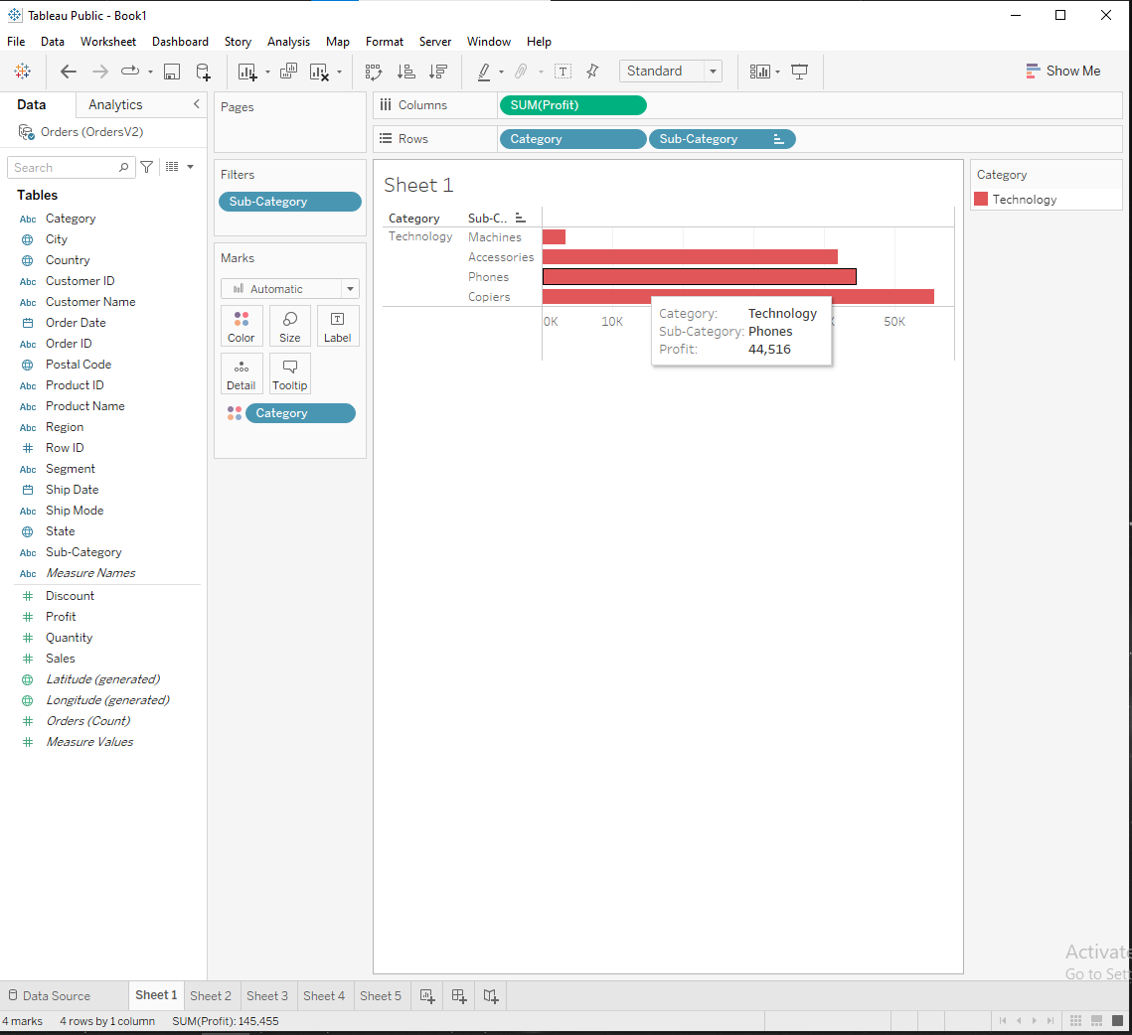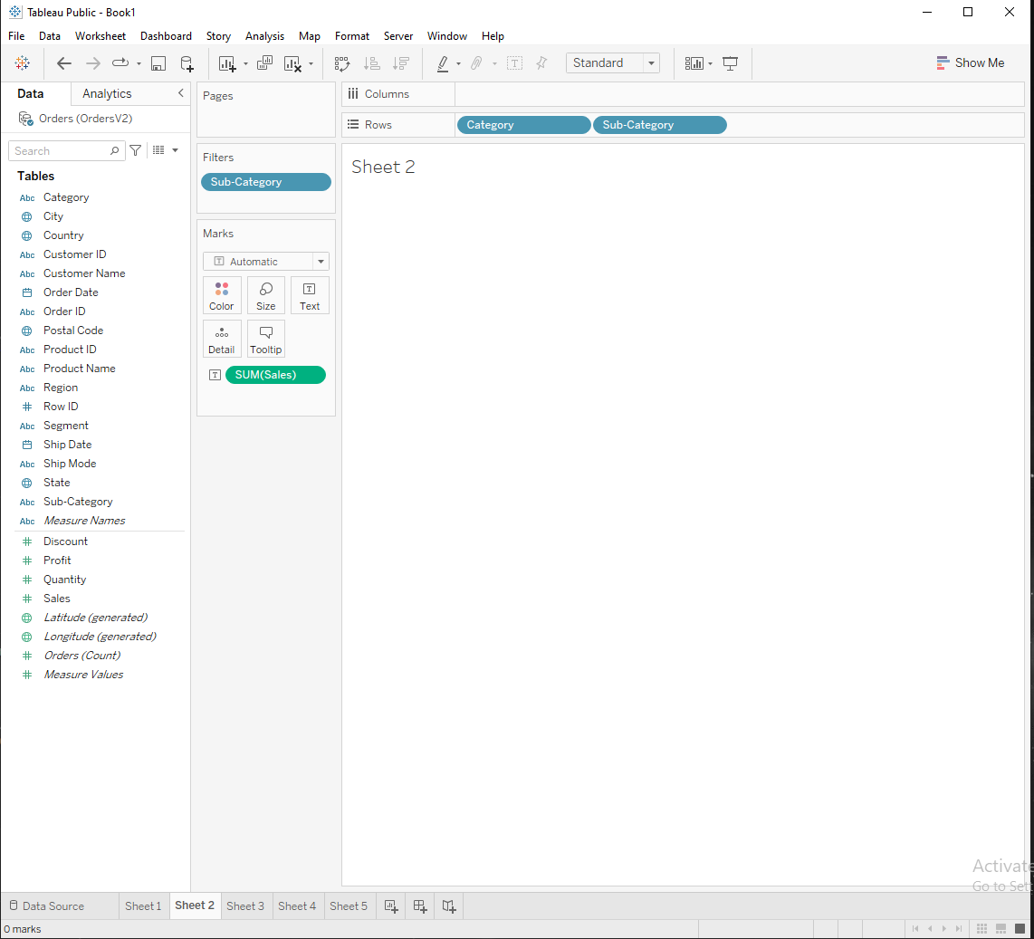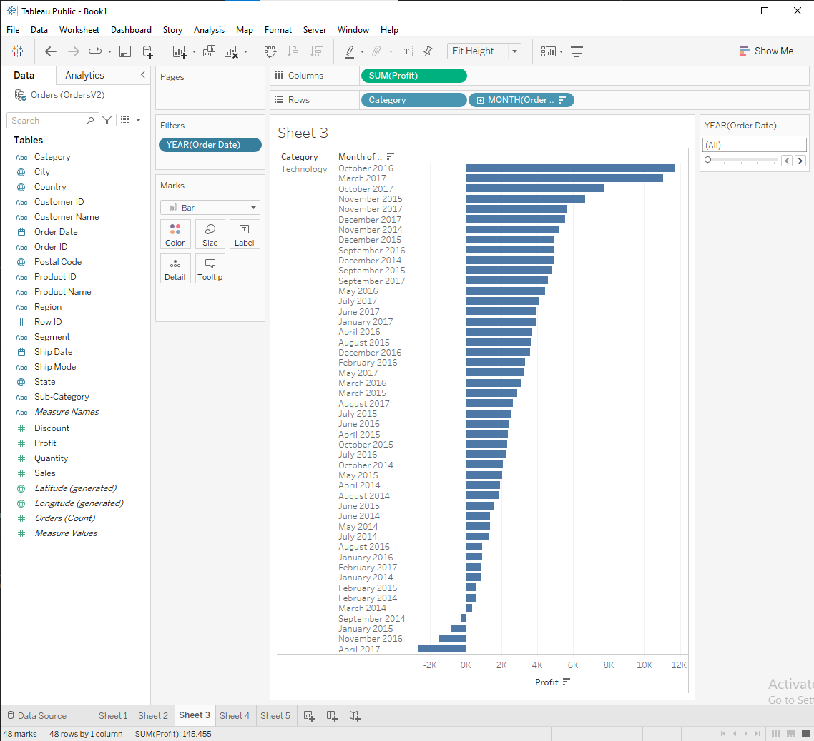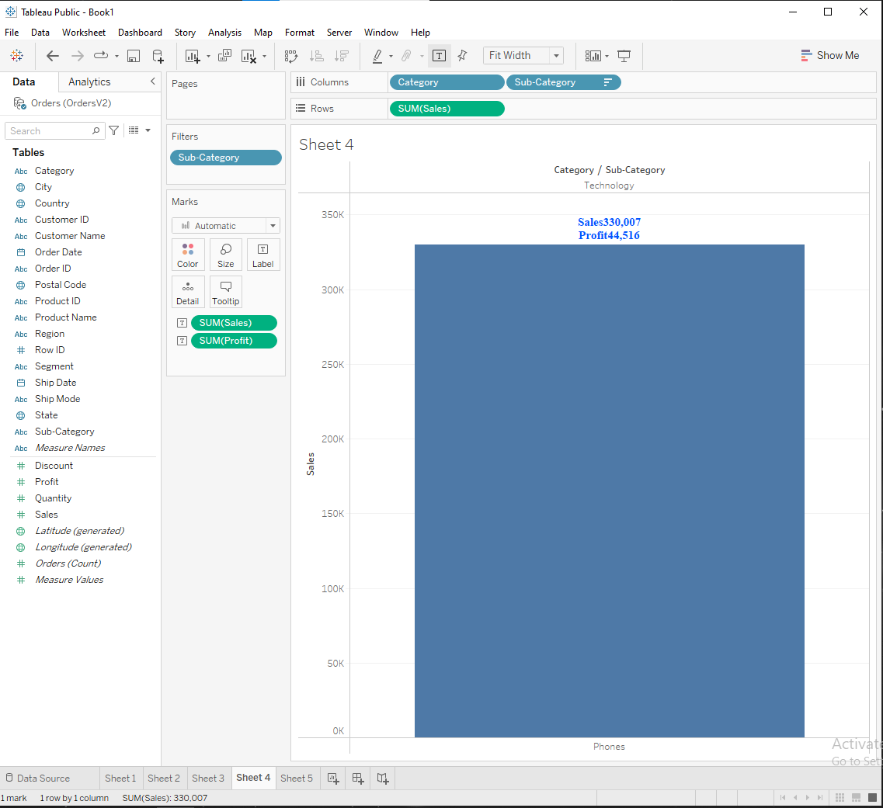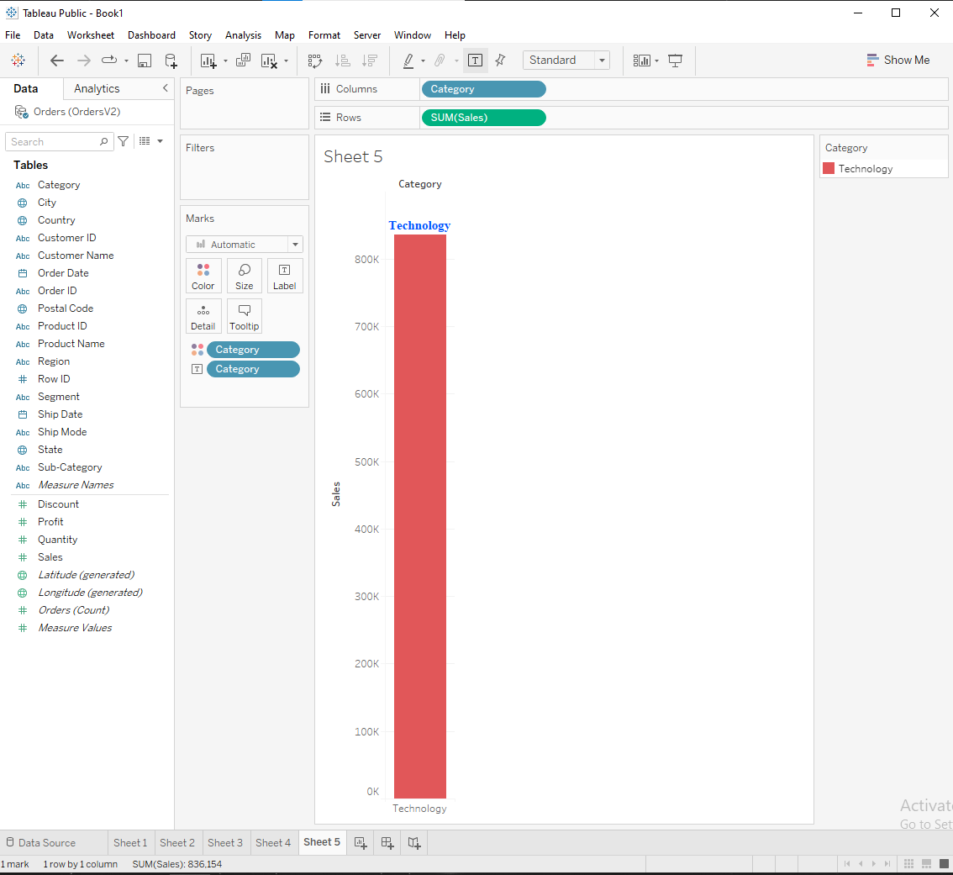

**16th assignment**

**Create a bar chart to represent region-wise profit. The Bars should also display category, sales & and profit value.**

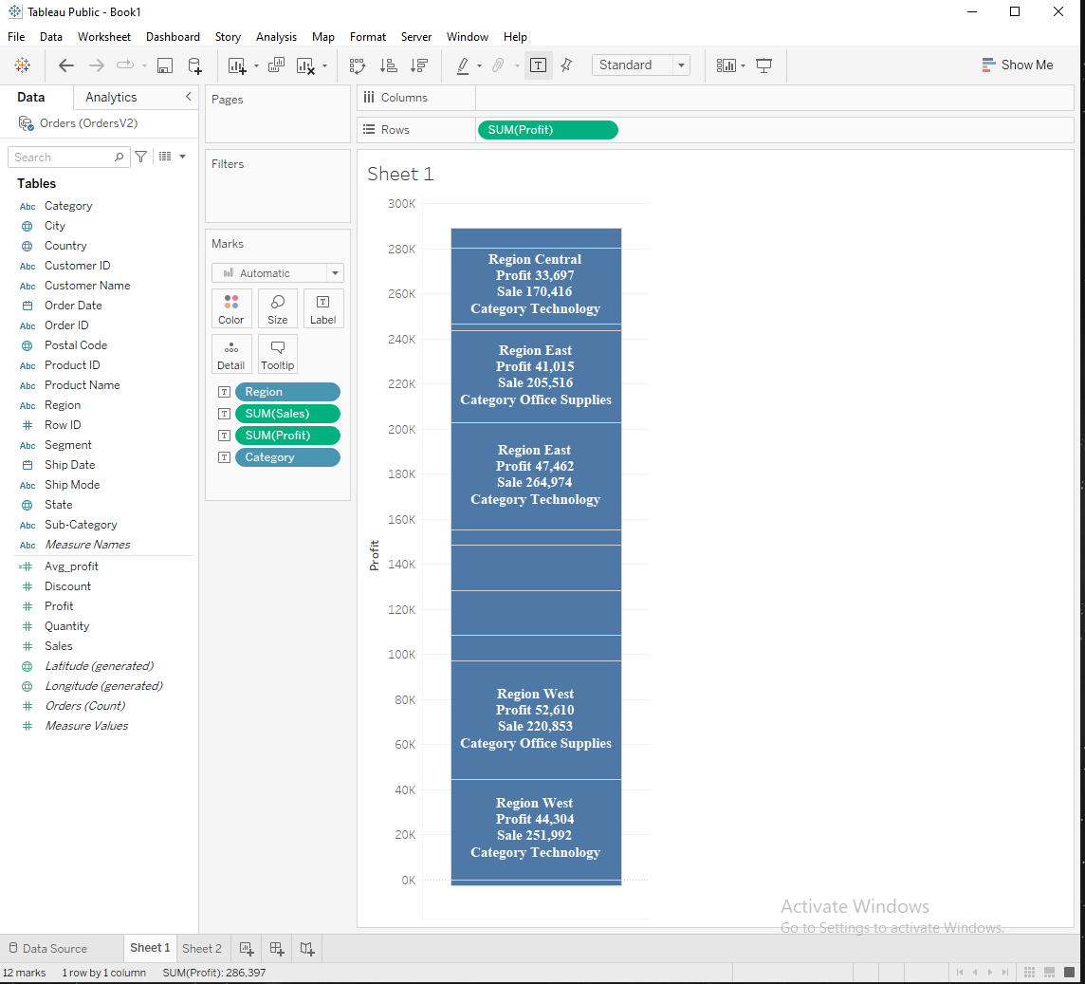

**17th assignment**

**Display sub-category-wise quantity sold & and average profit using a bar chart**

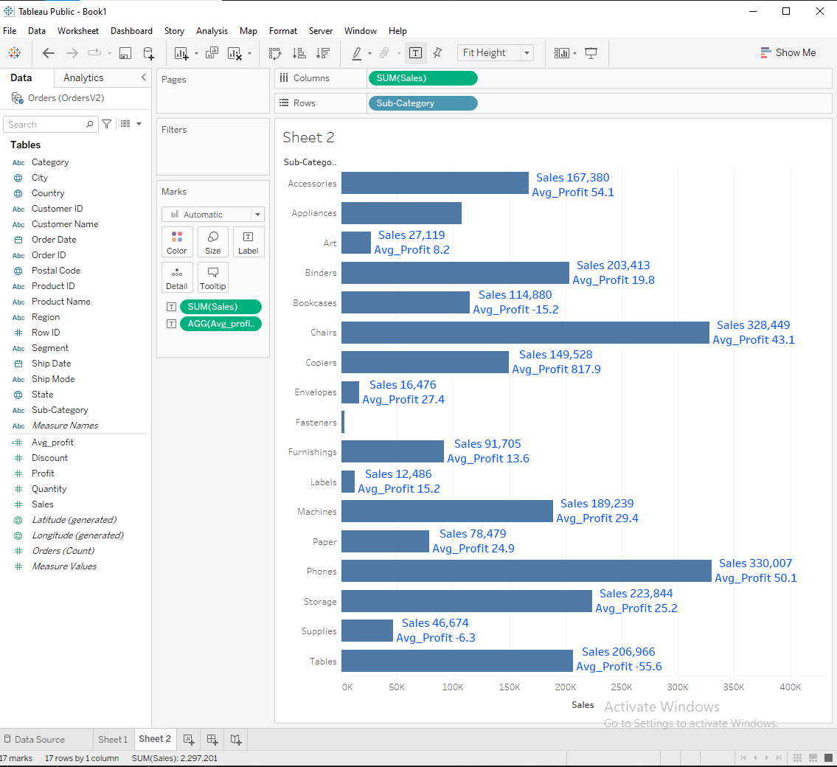

Class_3 Assignments

**Assignment_1**

**Display sub-category & Region wise profit in the tabular format. Format the worksheet with a black background. Font in bright color, no banding in rows/columns. The heading should be highlighted in a different color.**

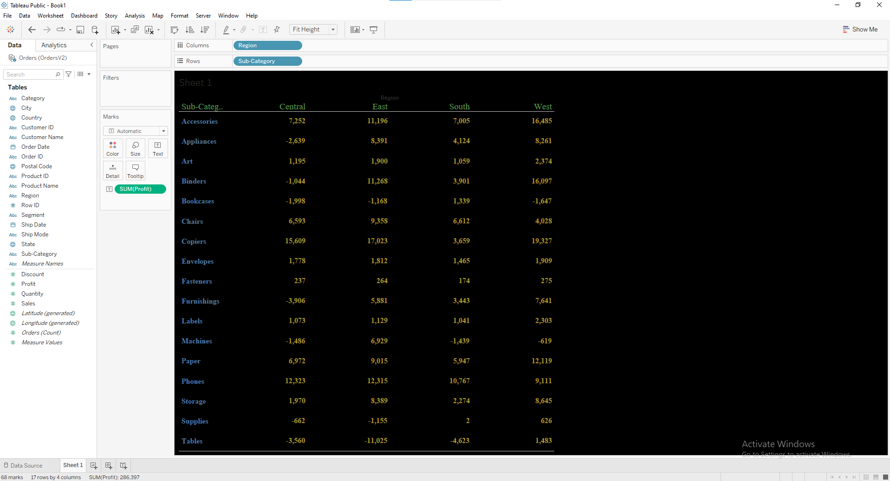

**Assignment_2**

**Display in the form of a horizontal bar chart category & subcategory-wise total sales & Sales percentage. The percentage should be concerning Category.**

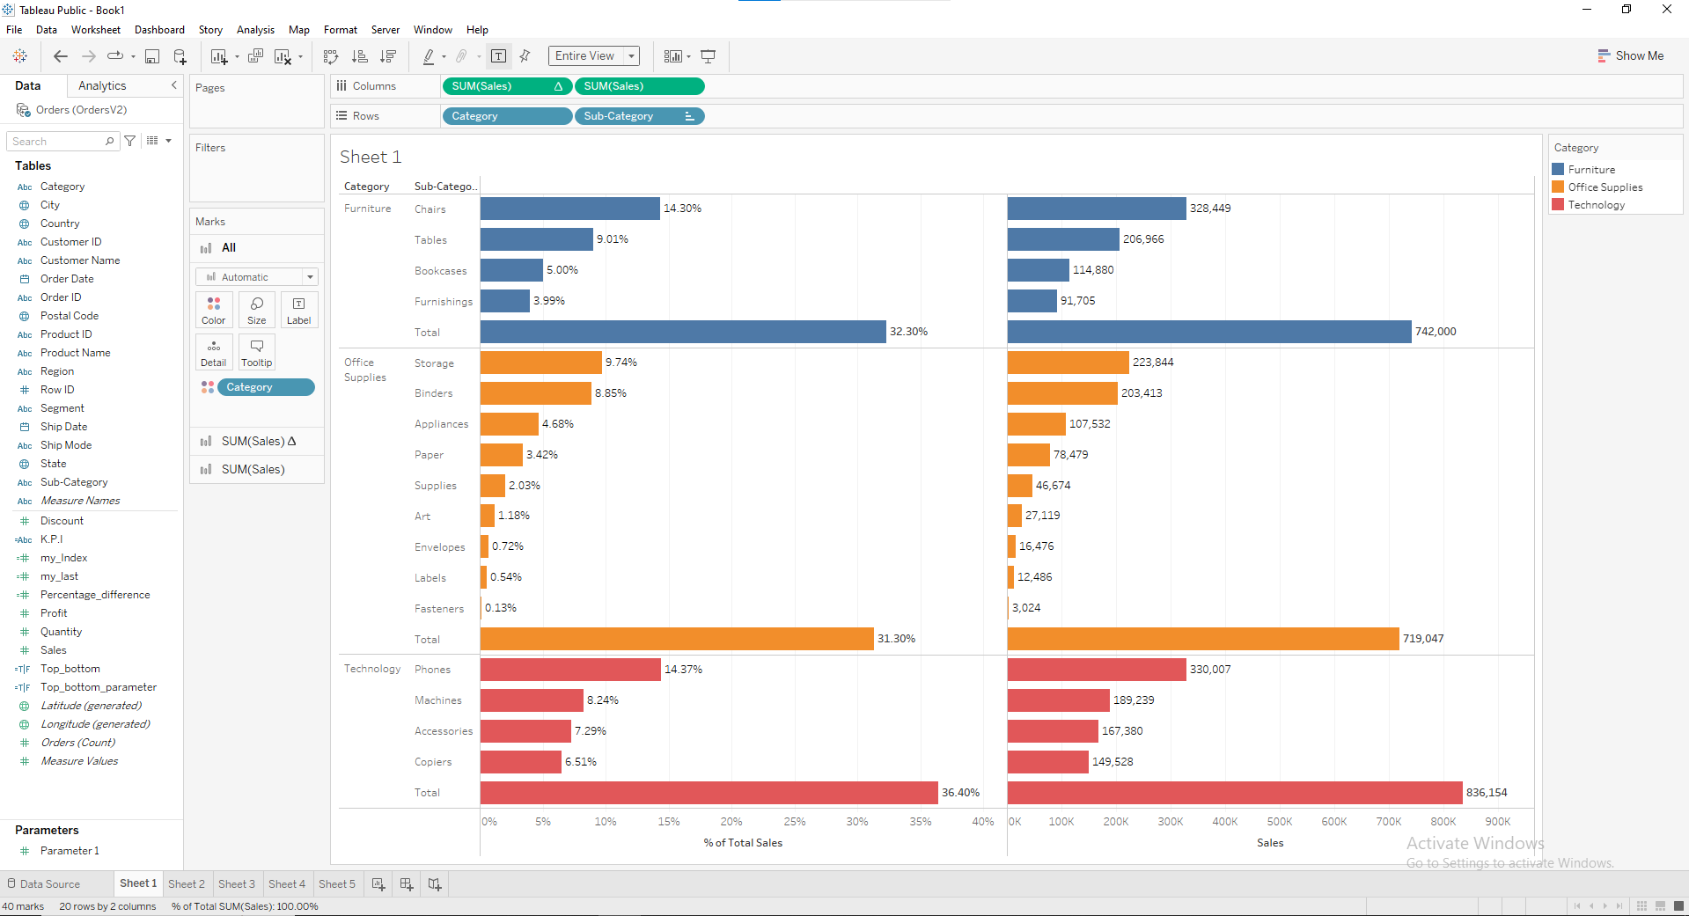

**Assignment_3**

**Represent year wise profit (running total )**

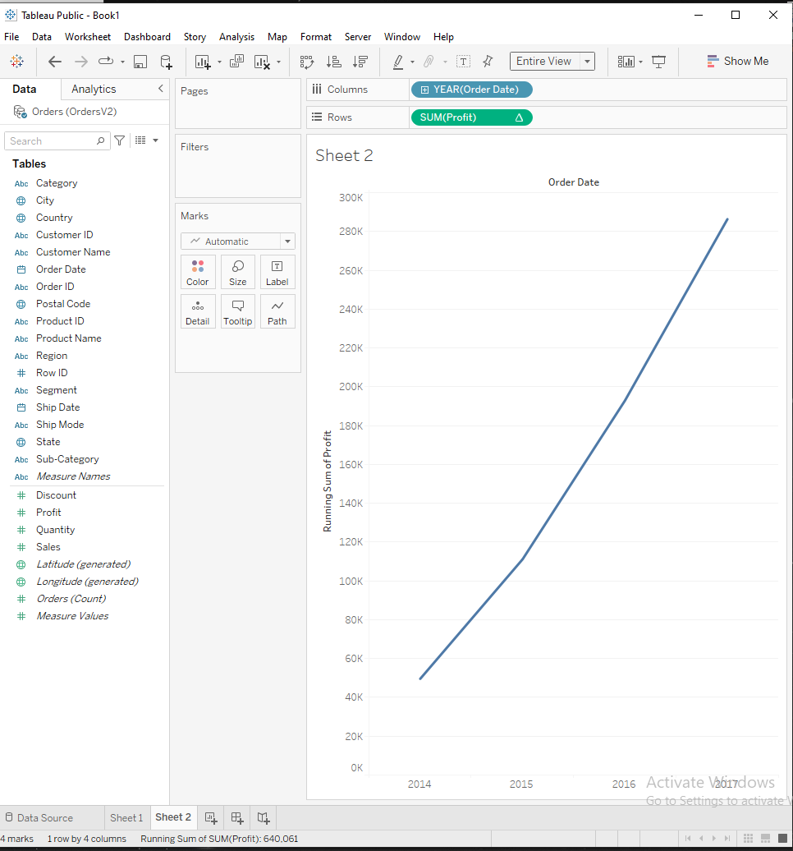

**Assignment_4**

**Represent subcategory-wise profit. Use conditional formatting to highlight top & bottom profit-generating subcategories. The number should be dynamic.**

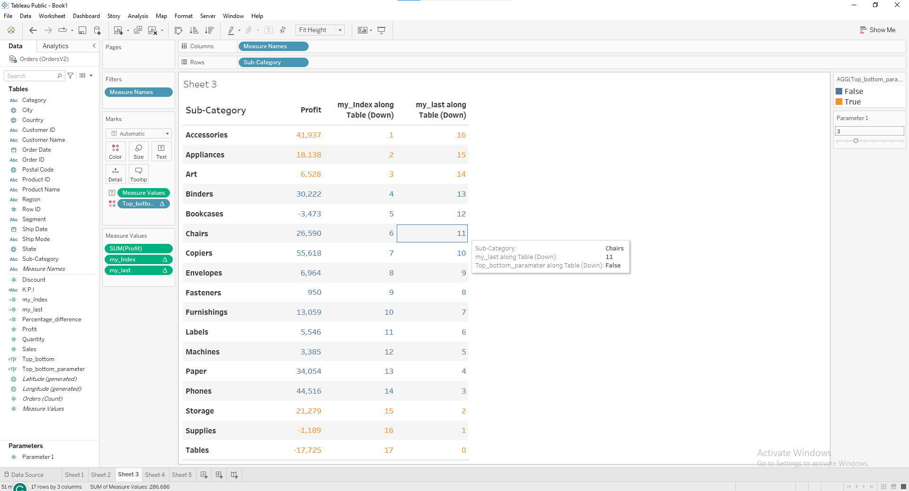

**Assignment_5**

**Display monthly profit in a tabular format. Order date should be interactive. Increase & decrease should be highlighted using the arrow.**

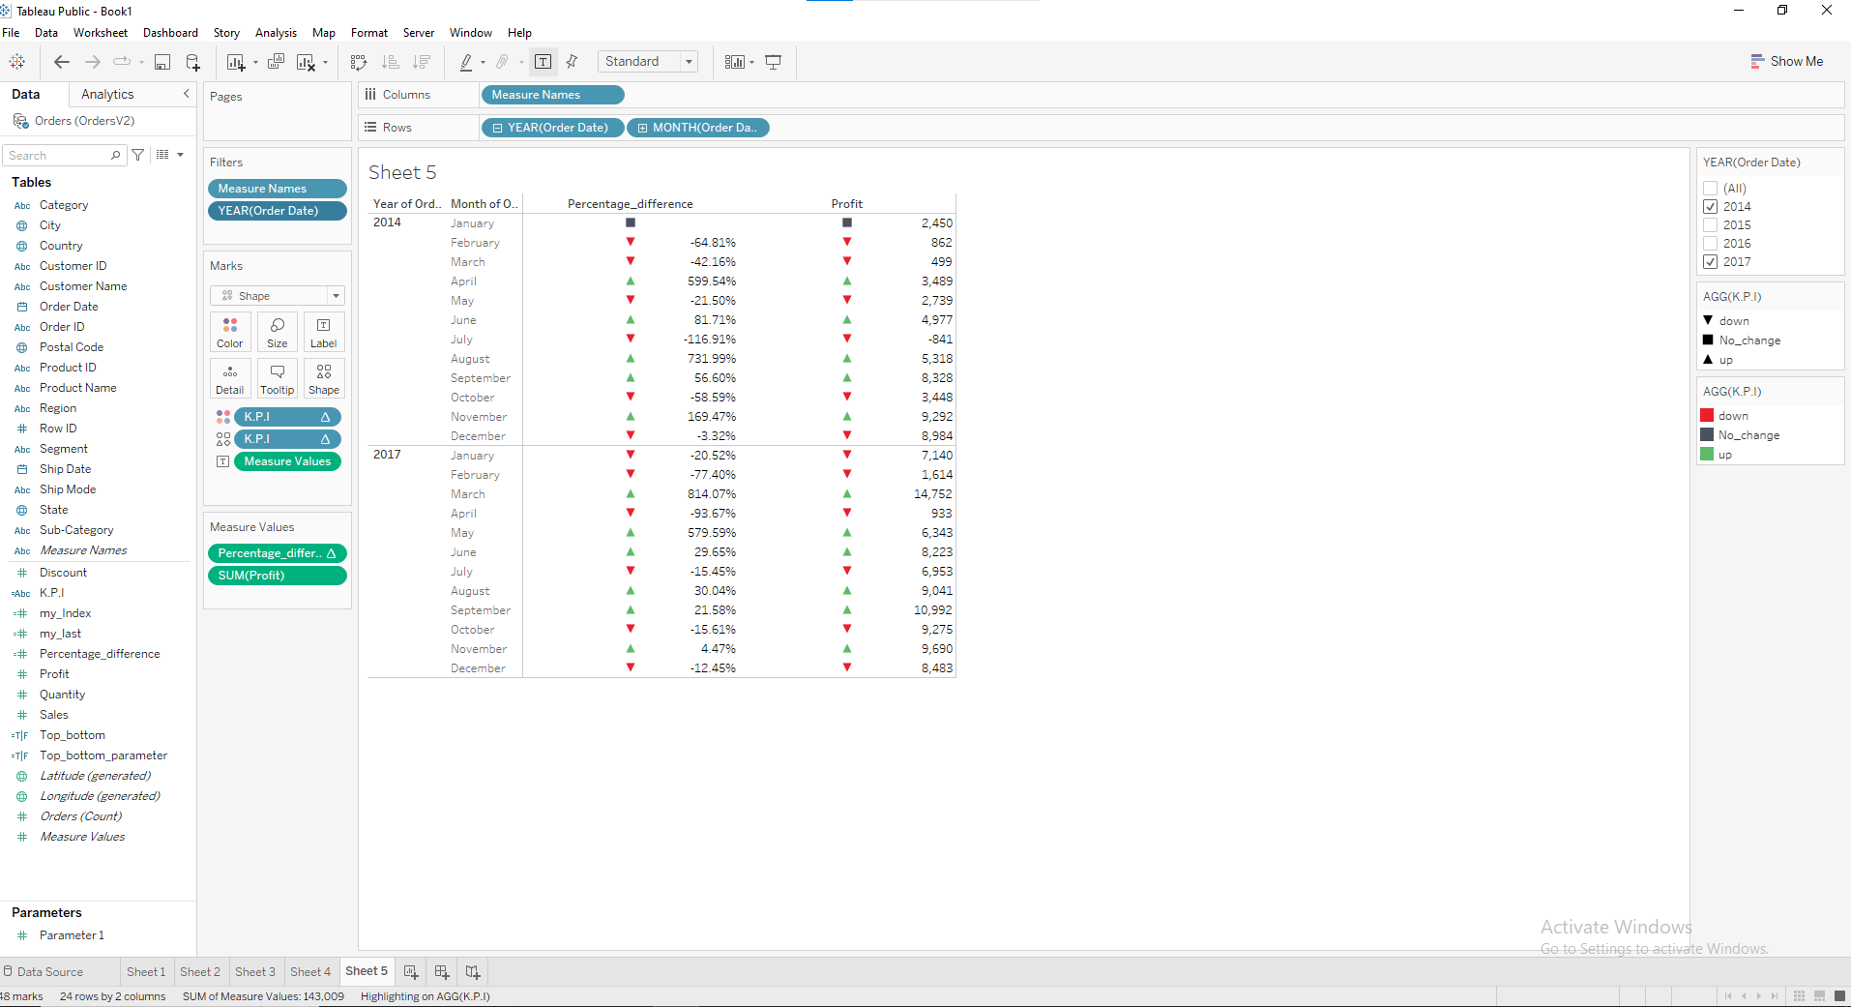

**CLASS 4th Assignments**

**1] Create a Scatter chart to represent profit & sales for each segment**

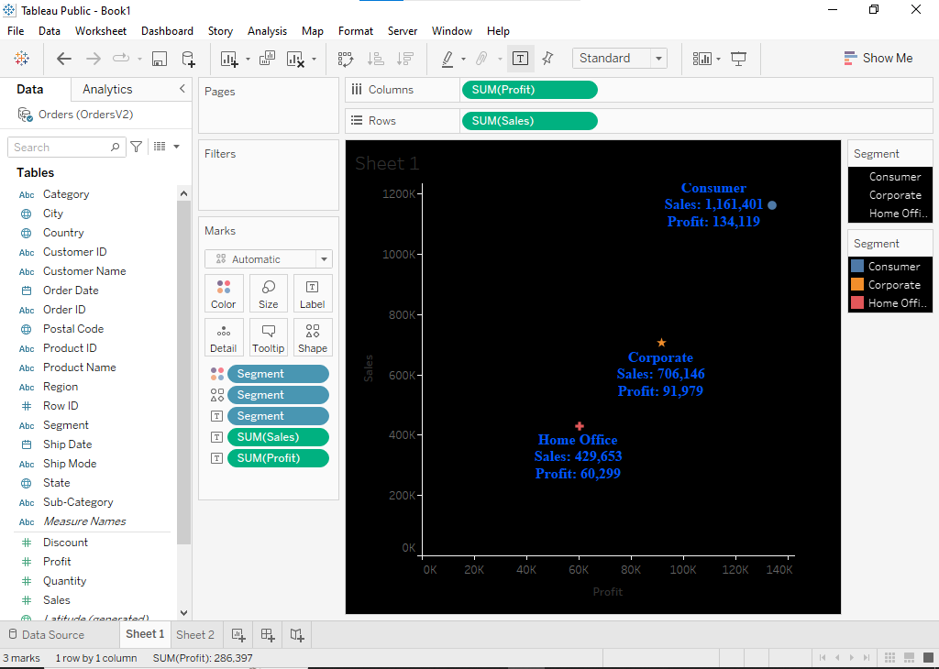

**2] Represent State wise sales using Word map**

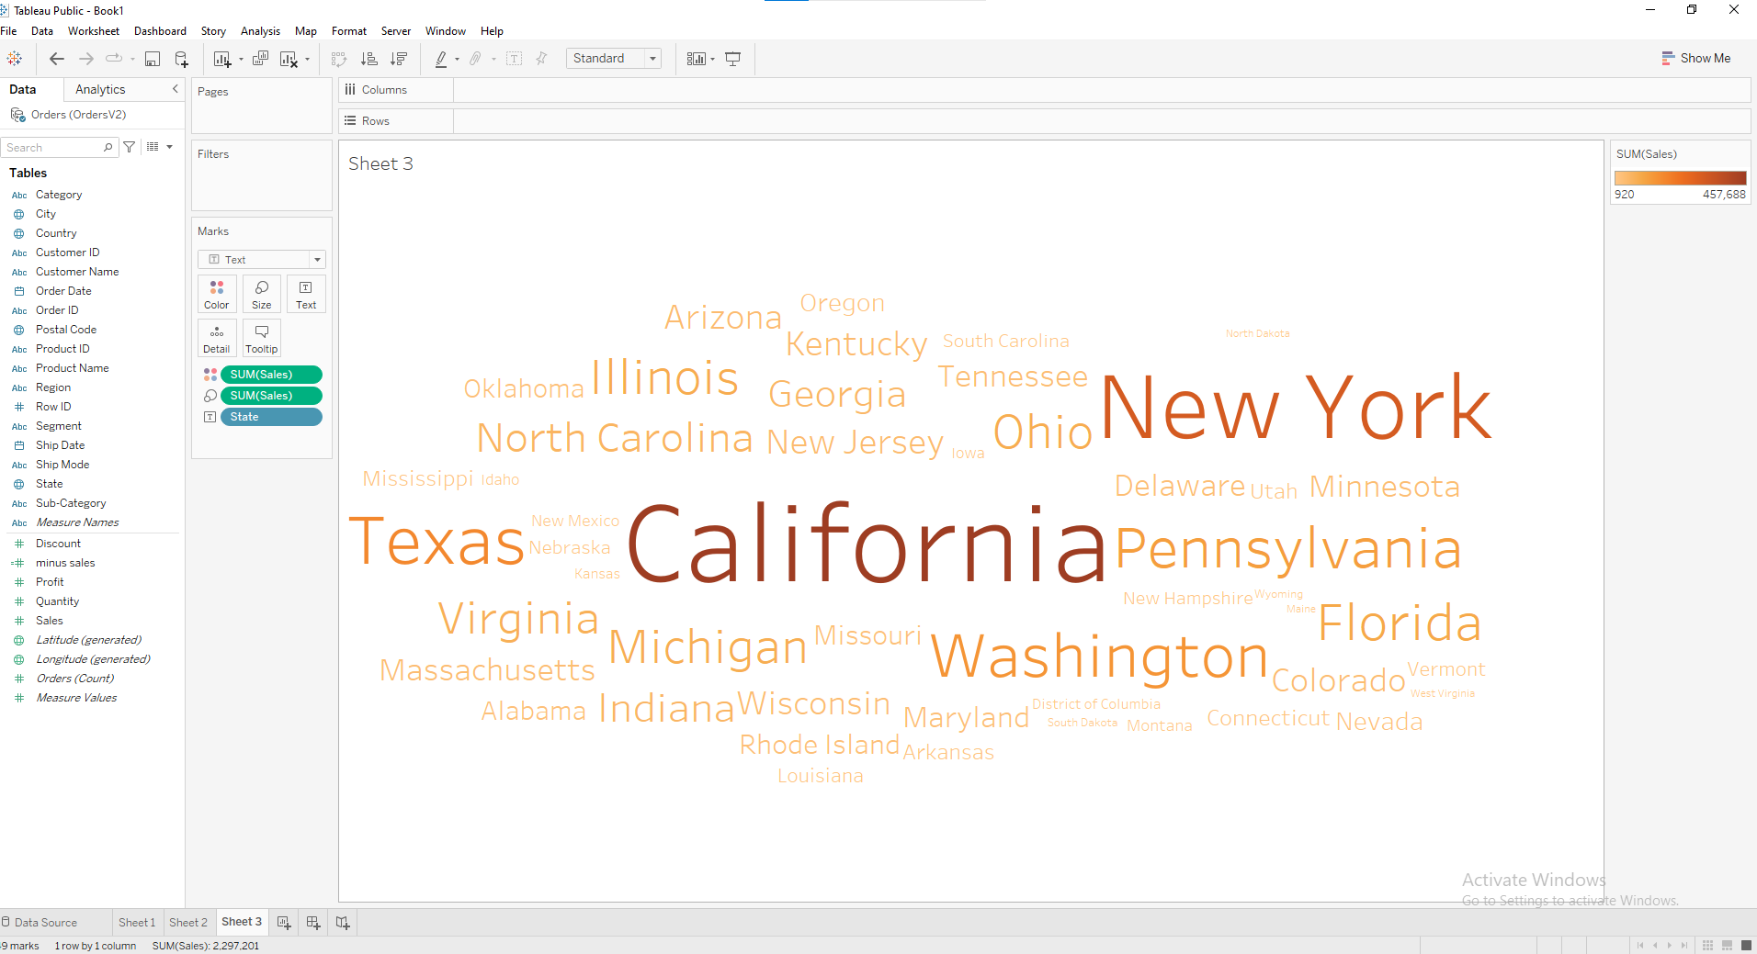

**3] Use a line graph to represent monthly Profit, Min & Max profit along with the month should be displayed.**

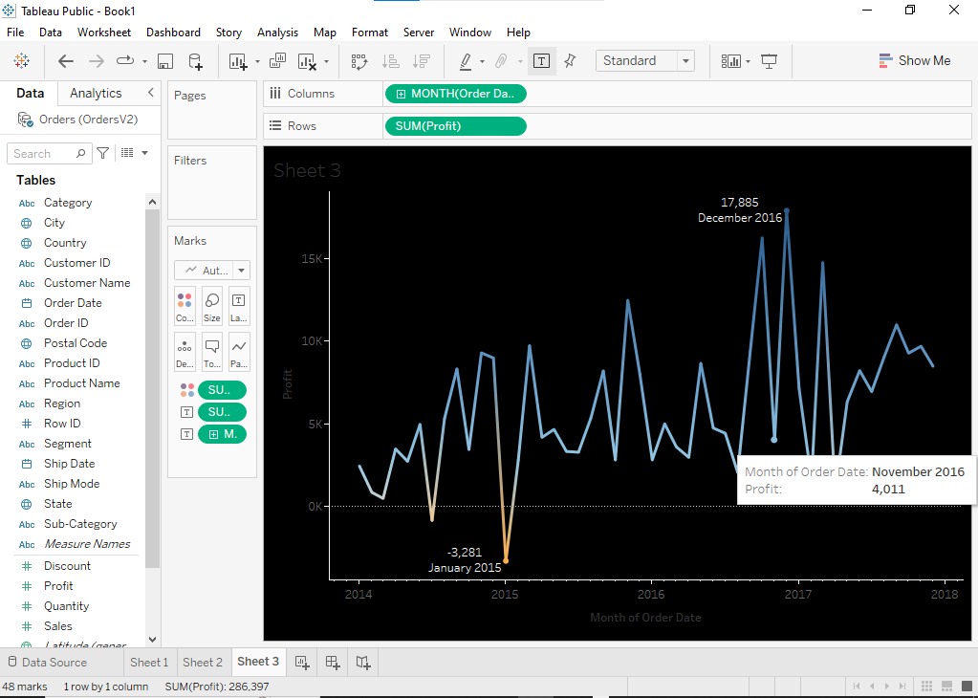

**4] Represent profit using a Bar chart category & Subcategory wise, focus should be on subcategories following above average (reference line)**

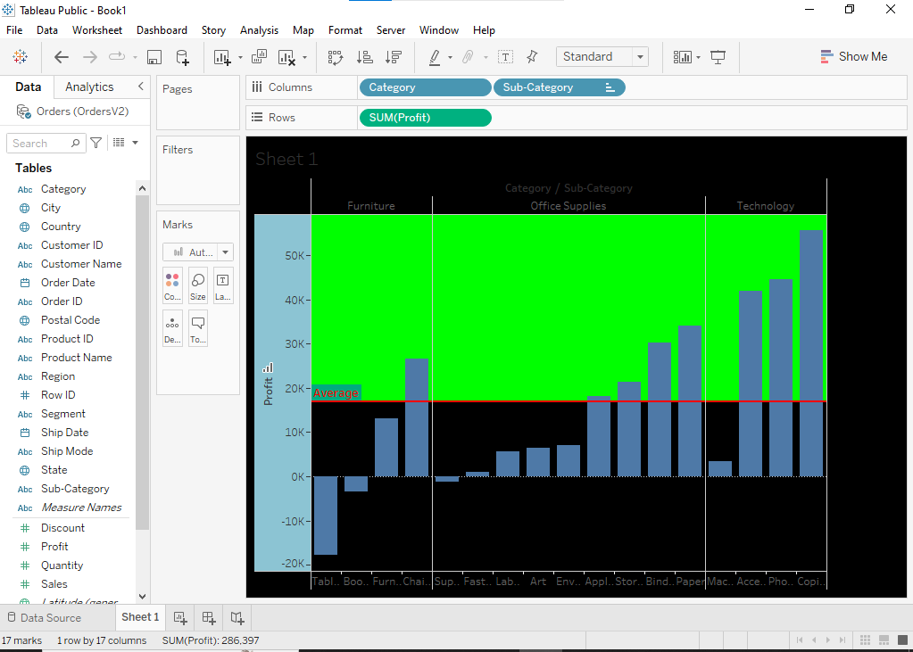

**5] Represent Region wise Sales & Profit using Bubble Chart**

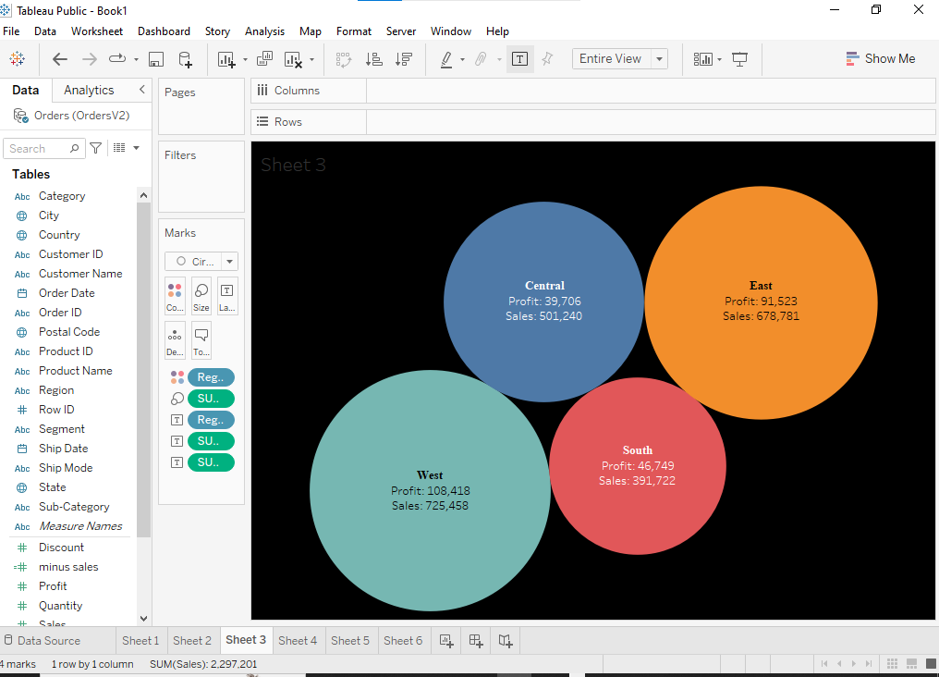

**6] Tree map to represent Category, Segment, and Region wise Sales**

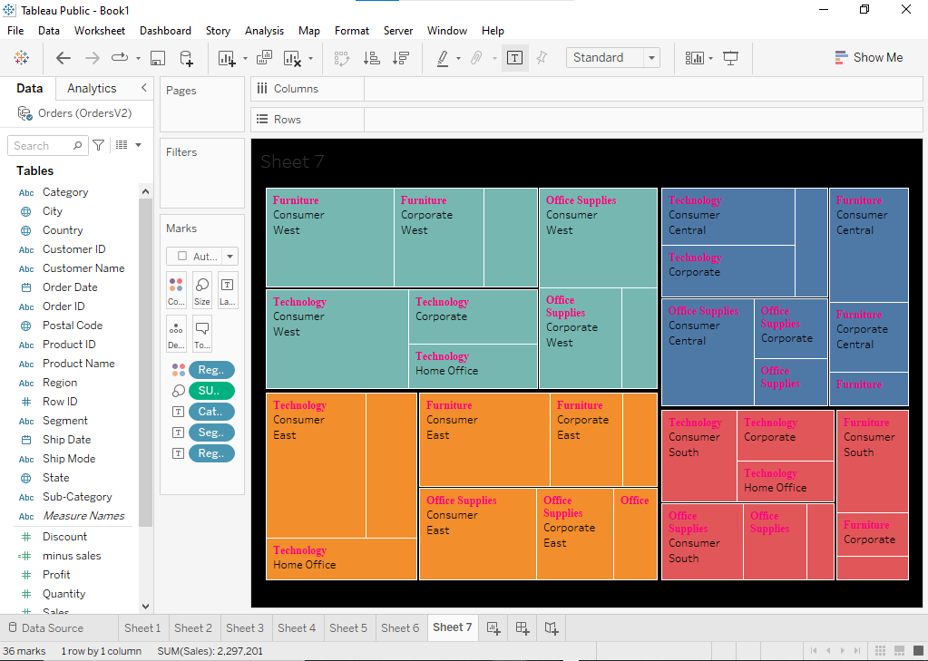

**7] Advance Funnel to represent subcategory Sales**

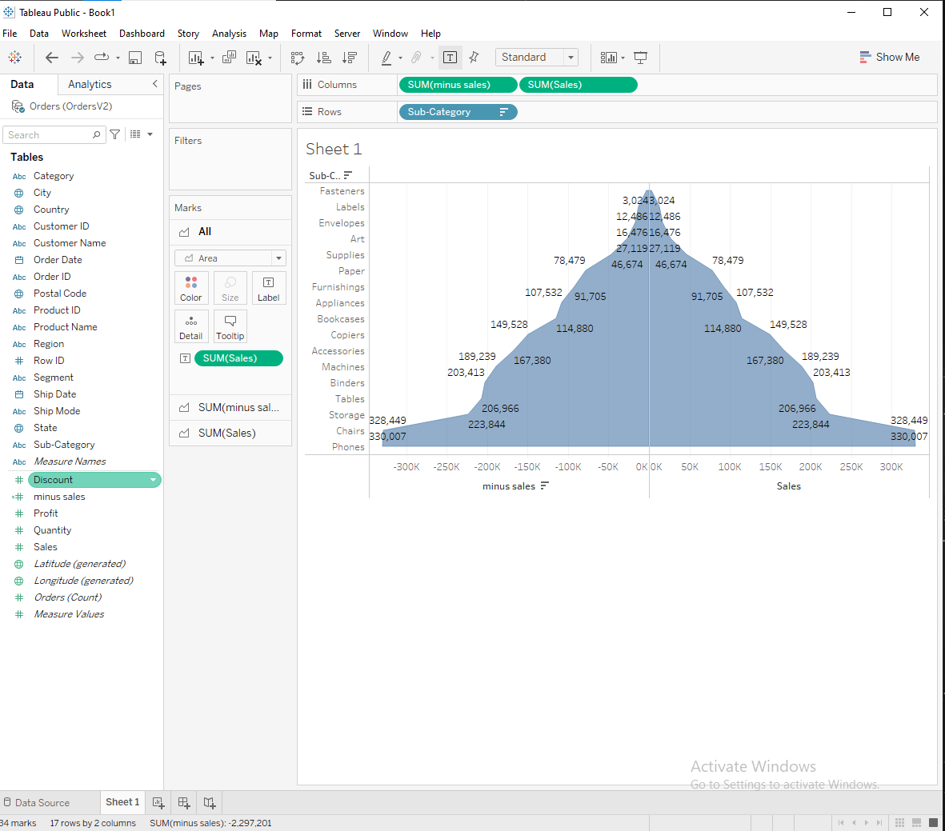

**] Represent segment wise profit using Pie Chart**

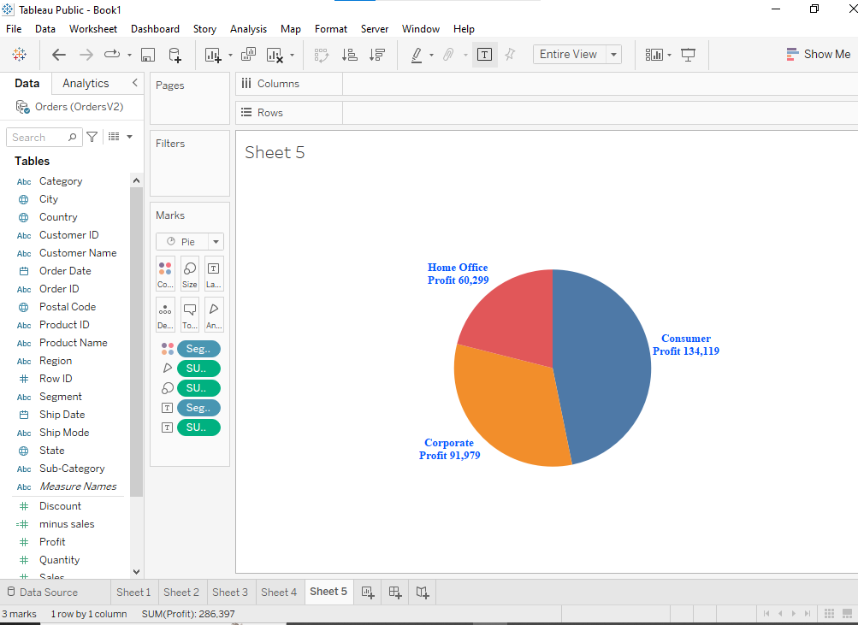

**9] Represent Subcategory wise profit using waterfall chart.**

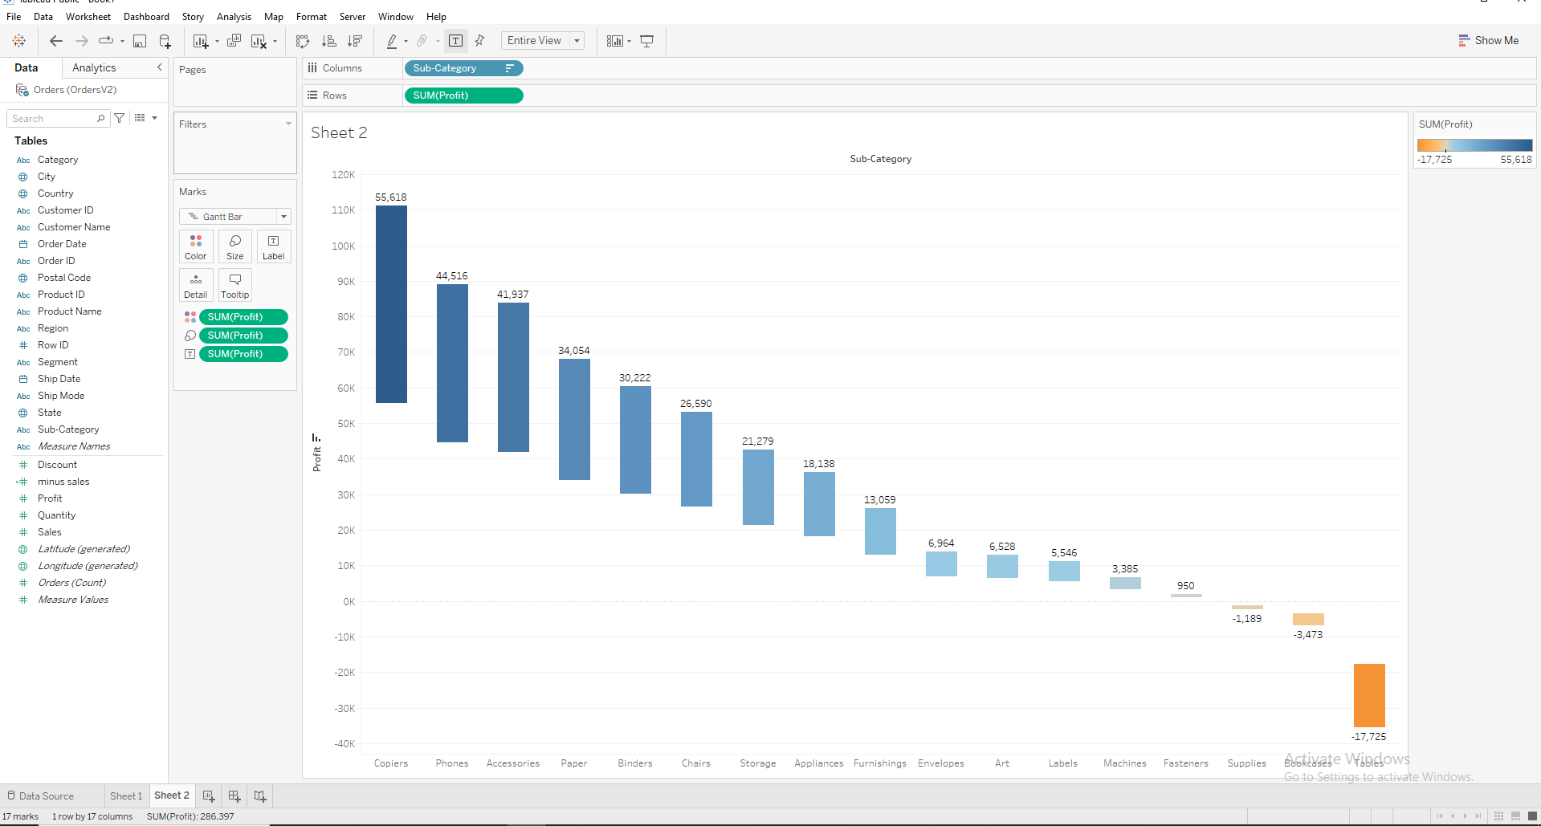

**Create a Category interactive sales bump chart to display subcategory wise bumps based on years.**

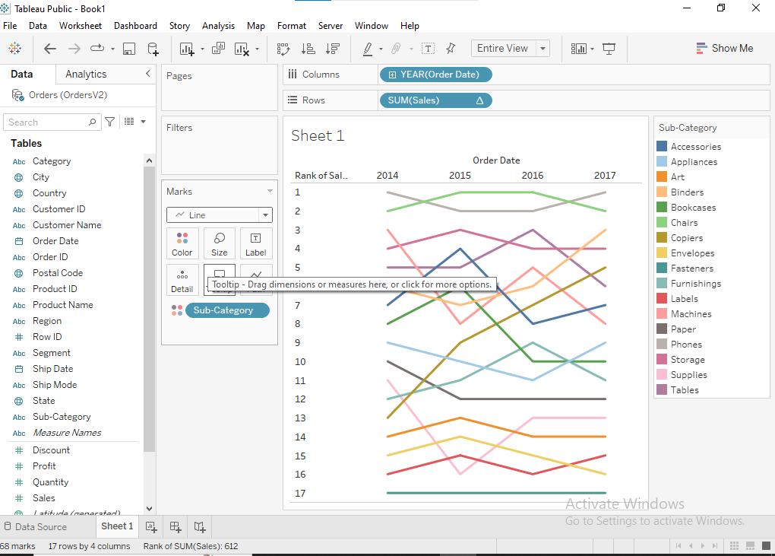

**Represent the state wise population percentage of India using MAP.**

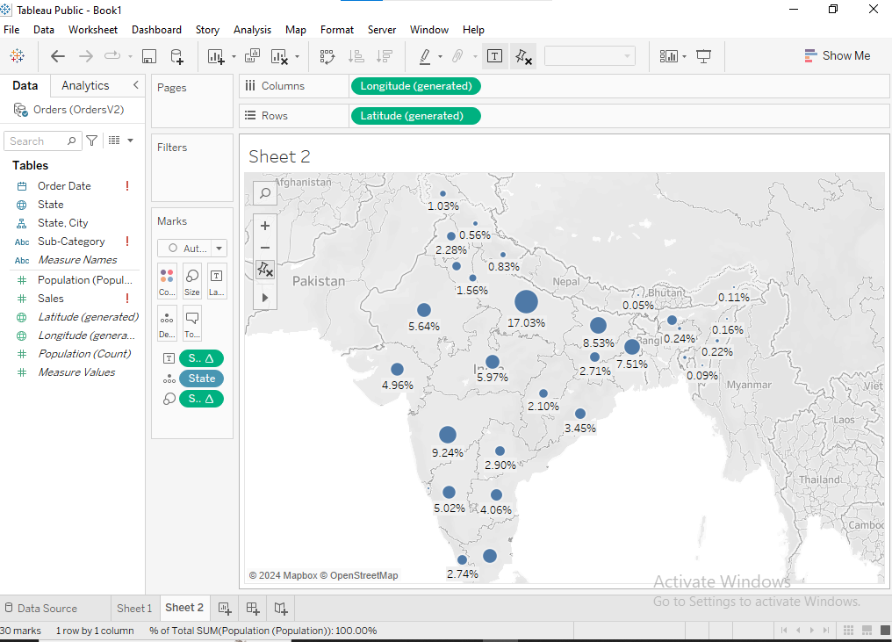

**Create a Region Interactive Horizontal Bar chart to represent Category & Subcategory wise Profit. The Chart should also display Dynamic Title & Caption.**

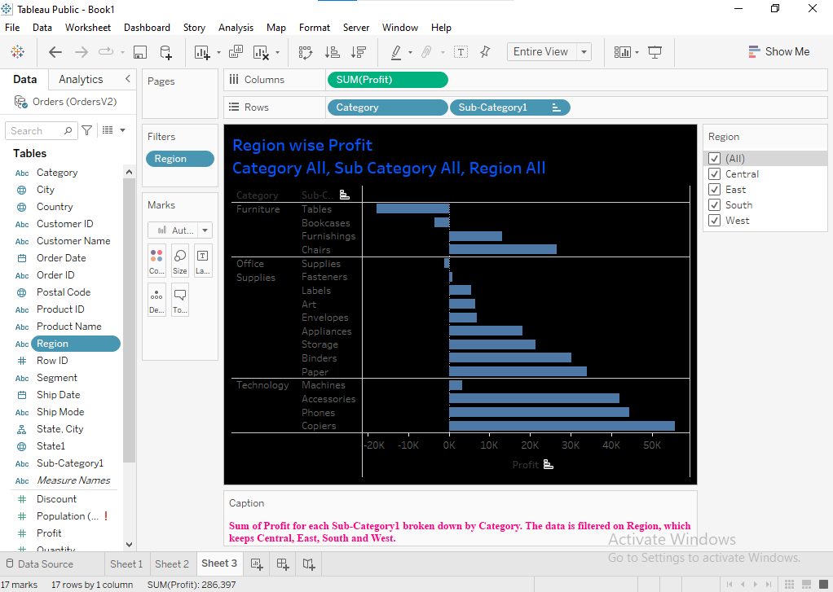

**Using India Map Represent state-wise percentage of Covid cases.**

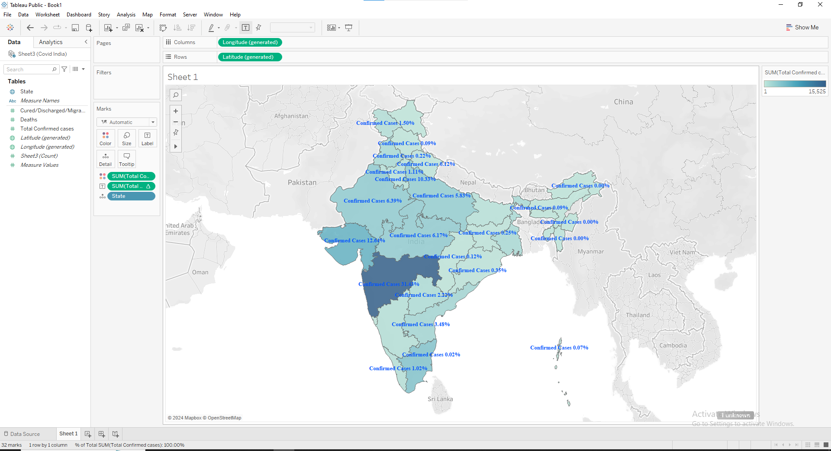

**In the other sheet, create a bar chart to represent state-wise Total Covid Cases, Recovered & Deaths.**

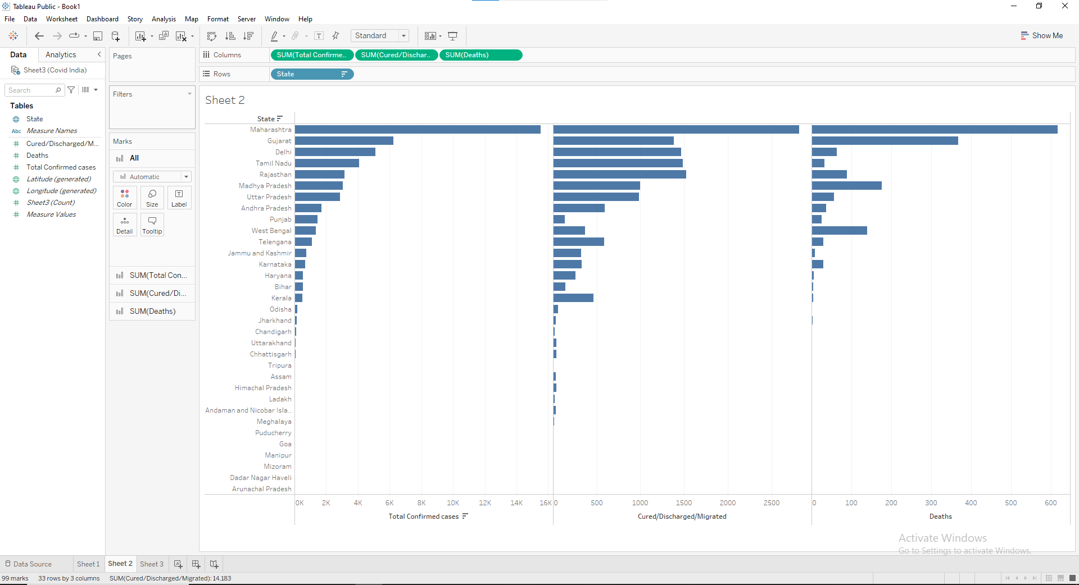

**Use action so that the bar graph representation of COVID-19 details should be displayed for the highlighted state.**

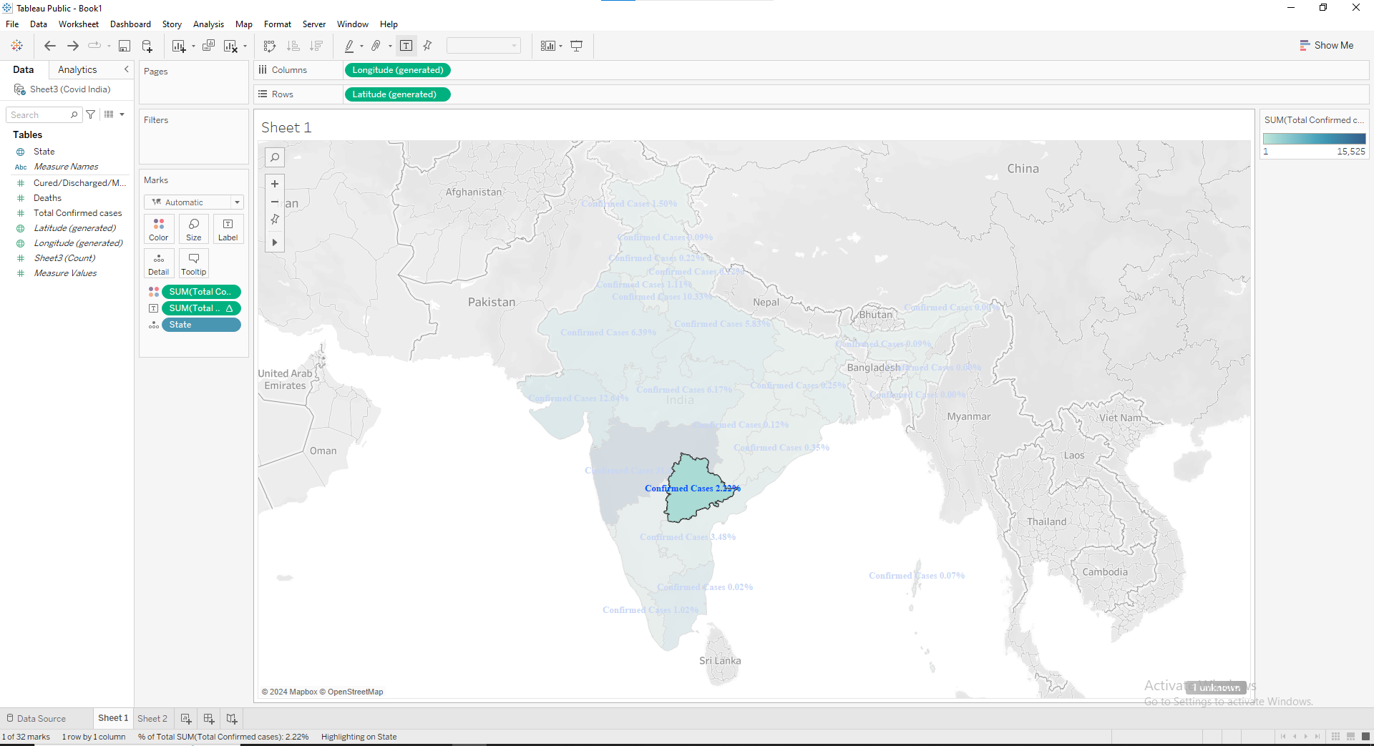 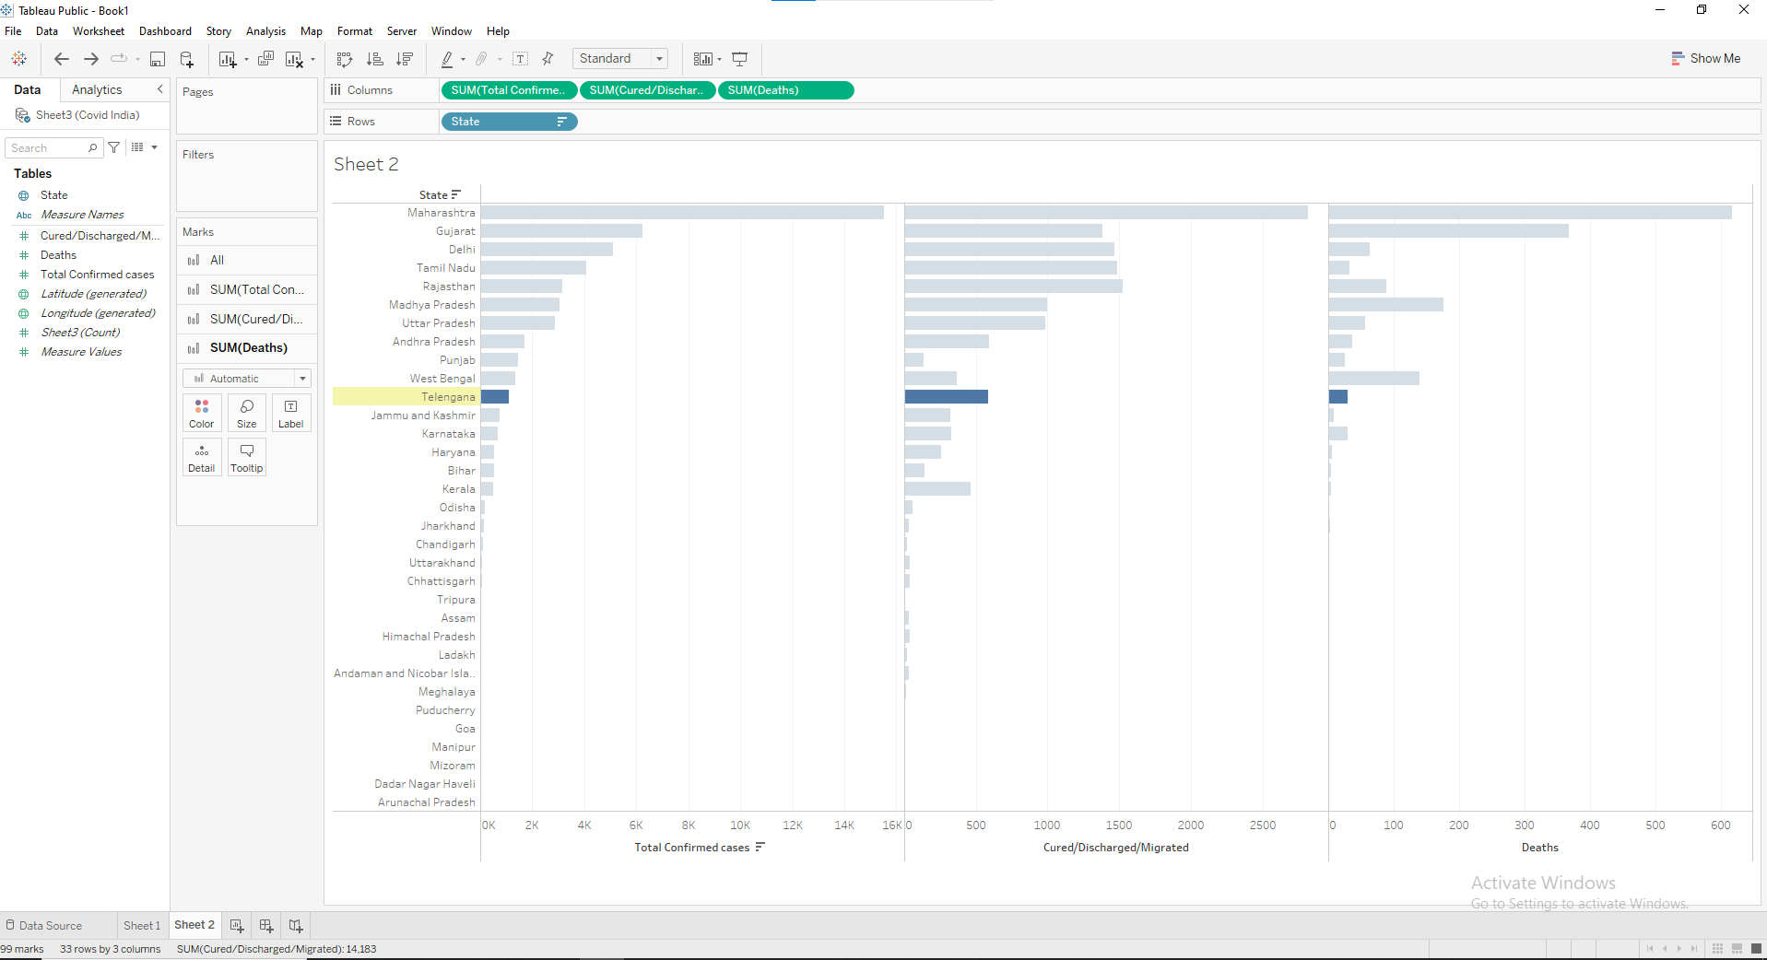

**Sheet 1 represents Category & Region wise profit, the category should be bifurcated based on region. • In sheet 2 represent Category, Subcategory & Region wise profit. • Implement an Action on sheet 1 so that sheet 2 is filtered on region & subcategory for the selected region in sheet 1.**

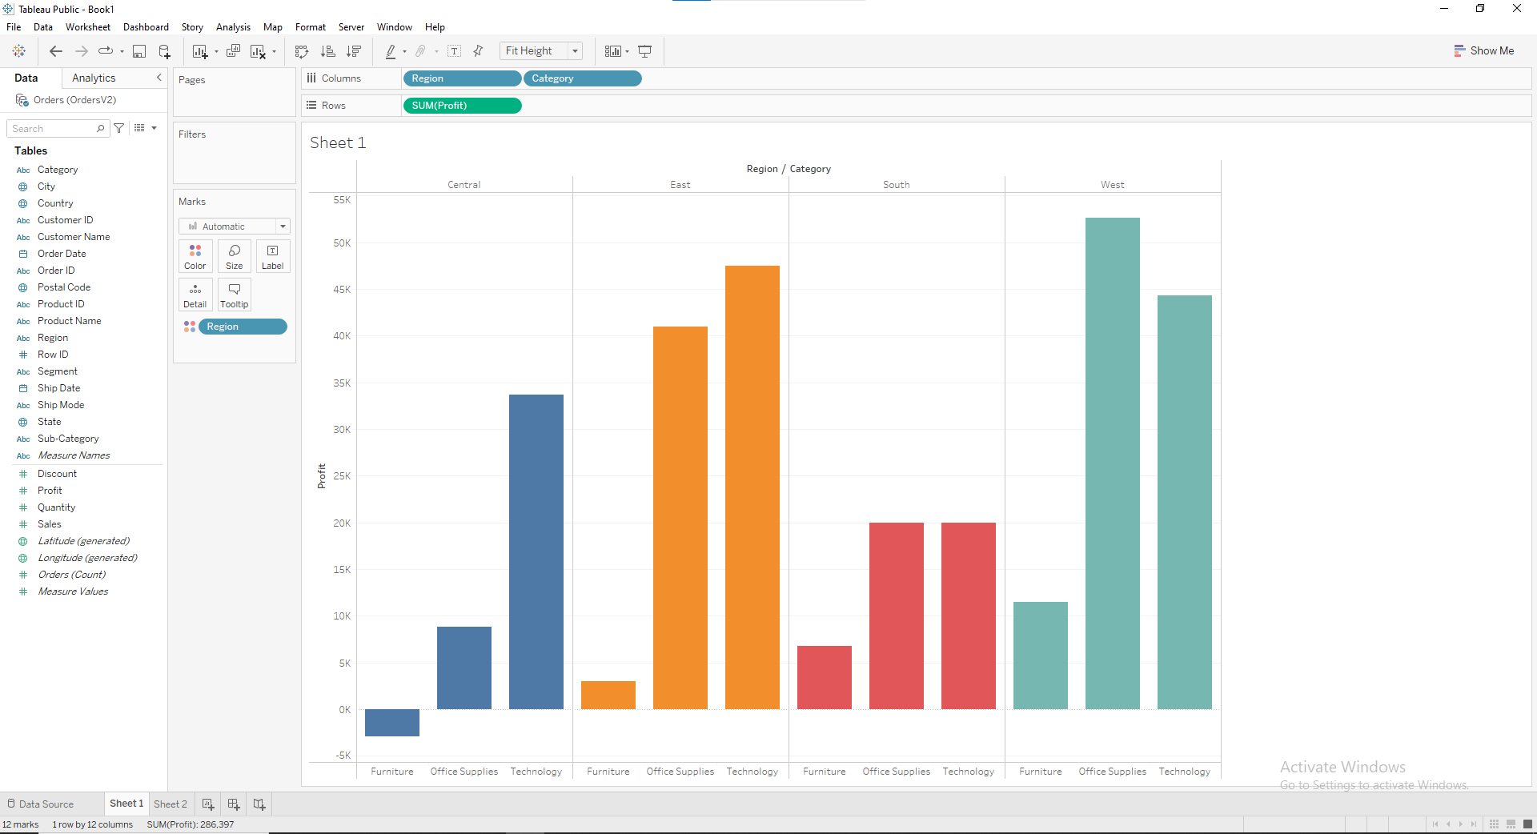 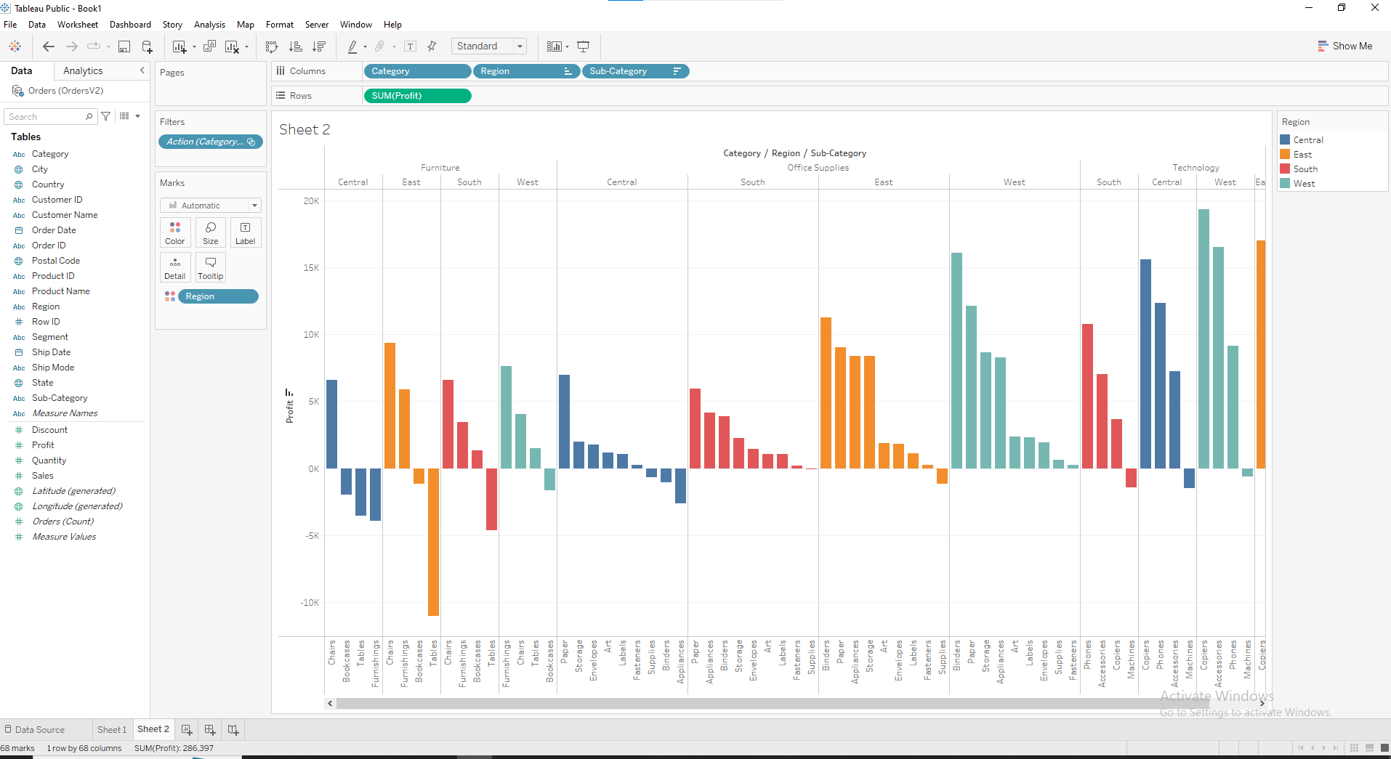

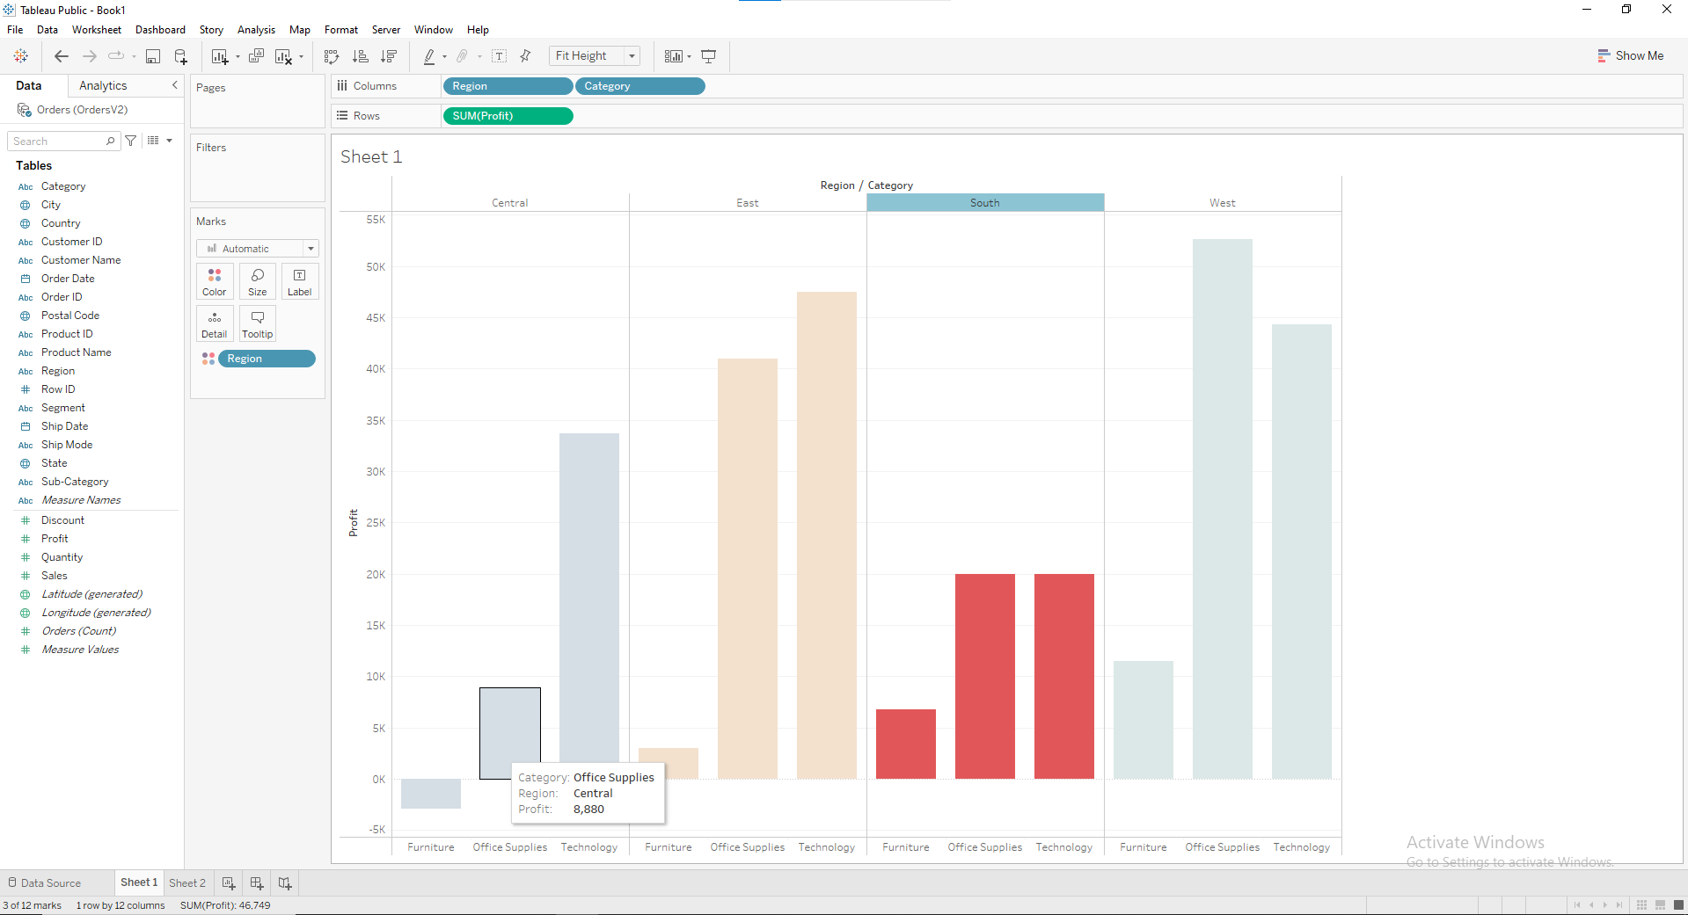 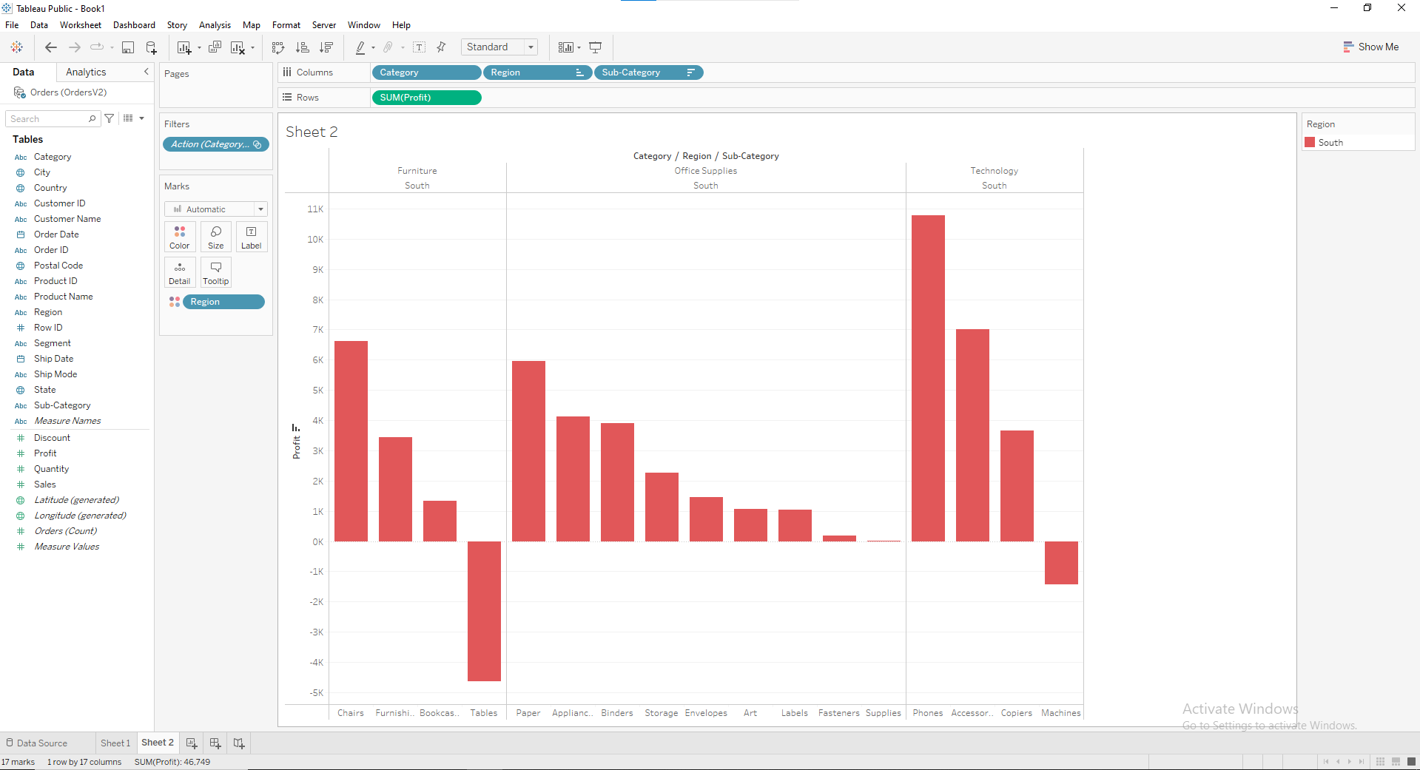

**Create a US Map to display the percentage sales contribution of each state. Implement a set action to give the sales comparison of the selected area**

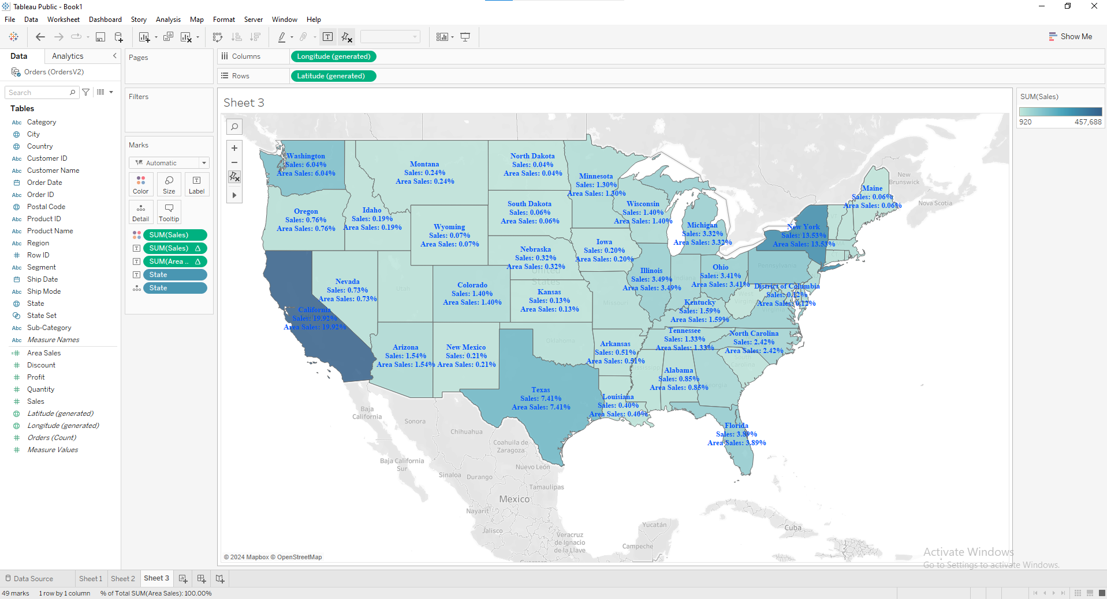

**After selecting one area**

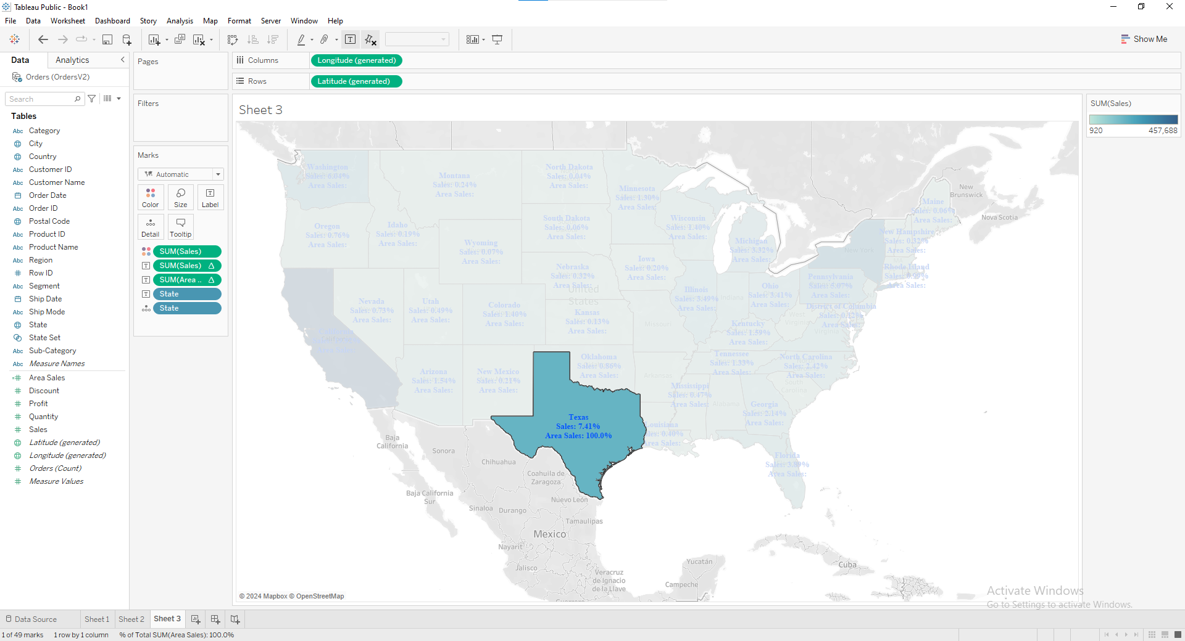

**Represent segment-wise profit using a bar chart Implement an action Parameter so that it can be drill down to region.**

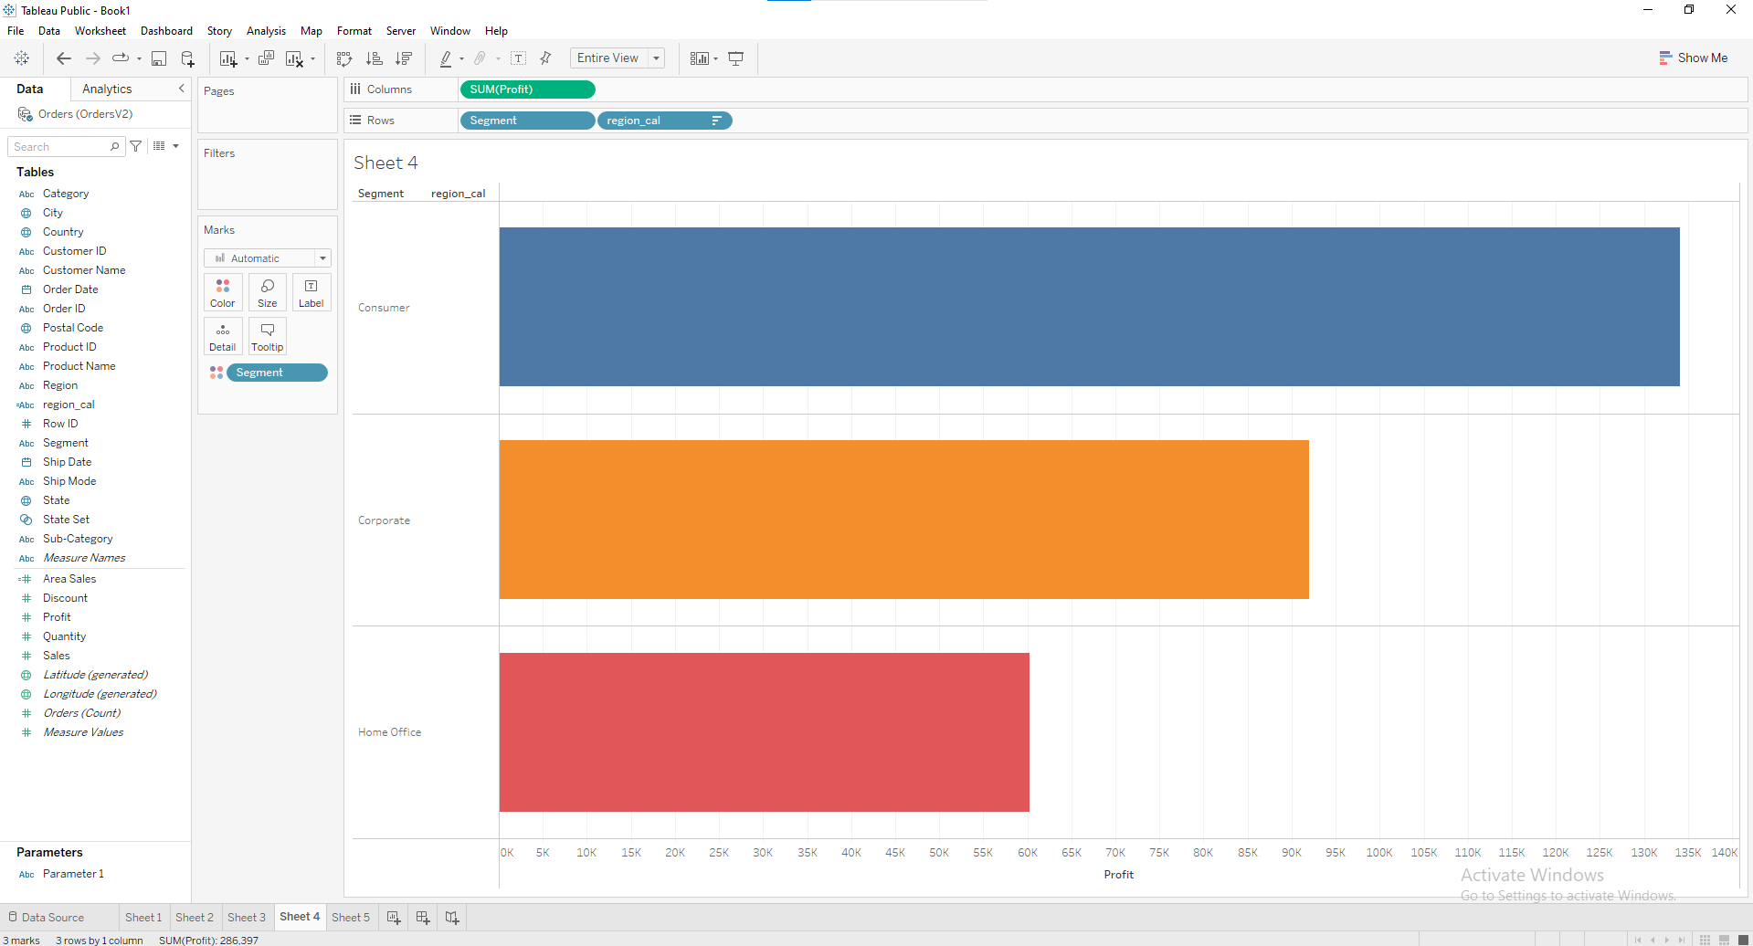

**After selecting one area**

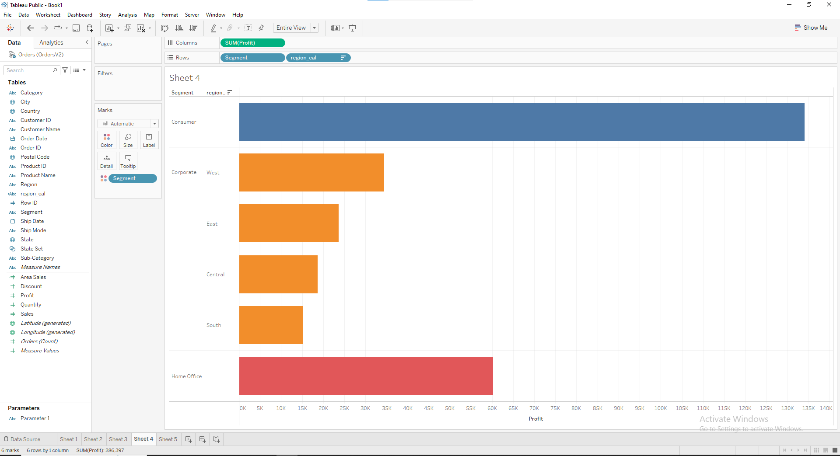

**Test**

**Que:2**

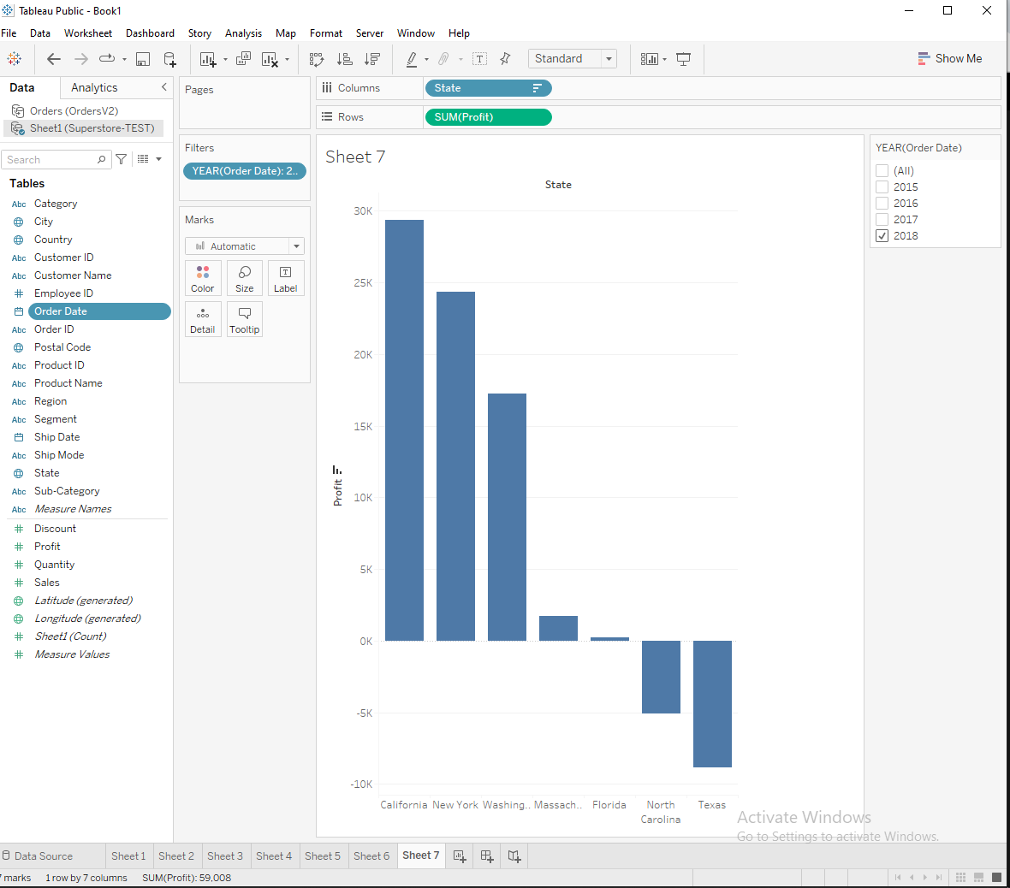

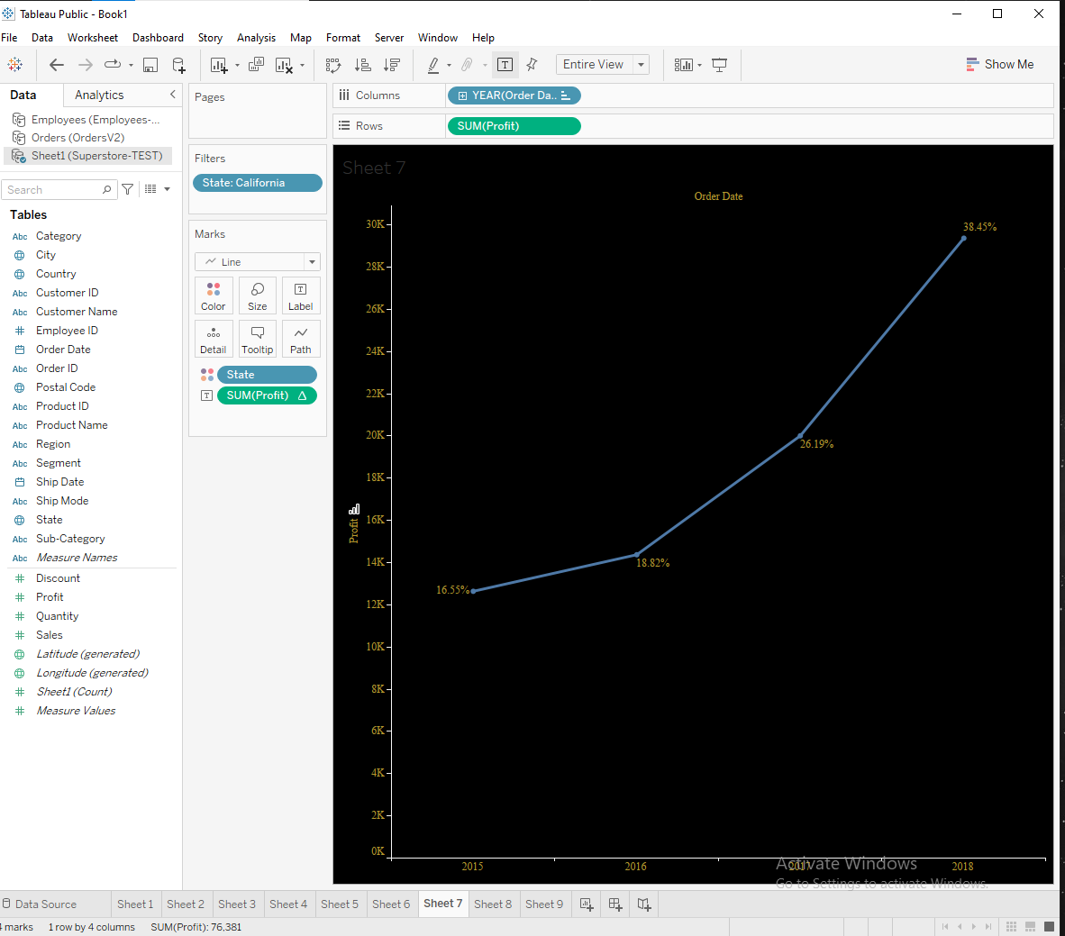

**Create a dashboard for a sample superstore sales summary which should present: • Year Wise sales for each region, • Percentage contribution of each region in overall sales. • State-wise revenue earned. • Category-wise Sales with region details. • Subcategory sales region-wise. The dashboard should be interactive based on Region.**

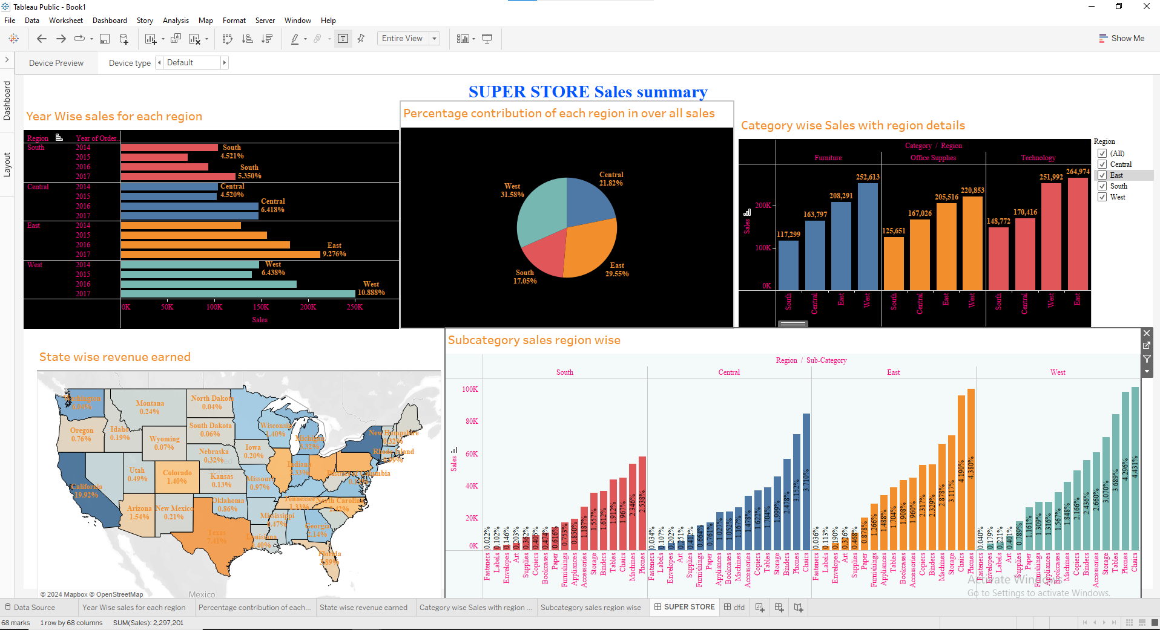

**After applying filter**

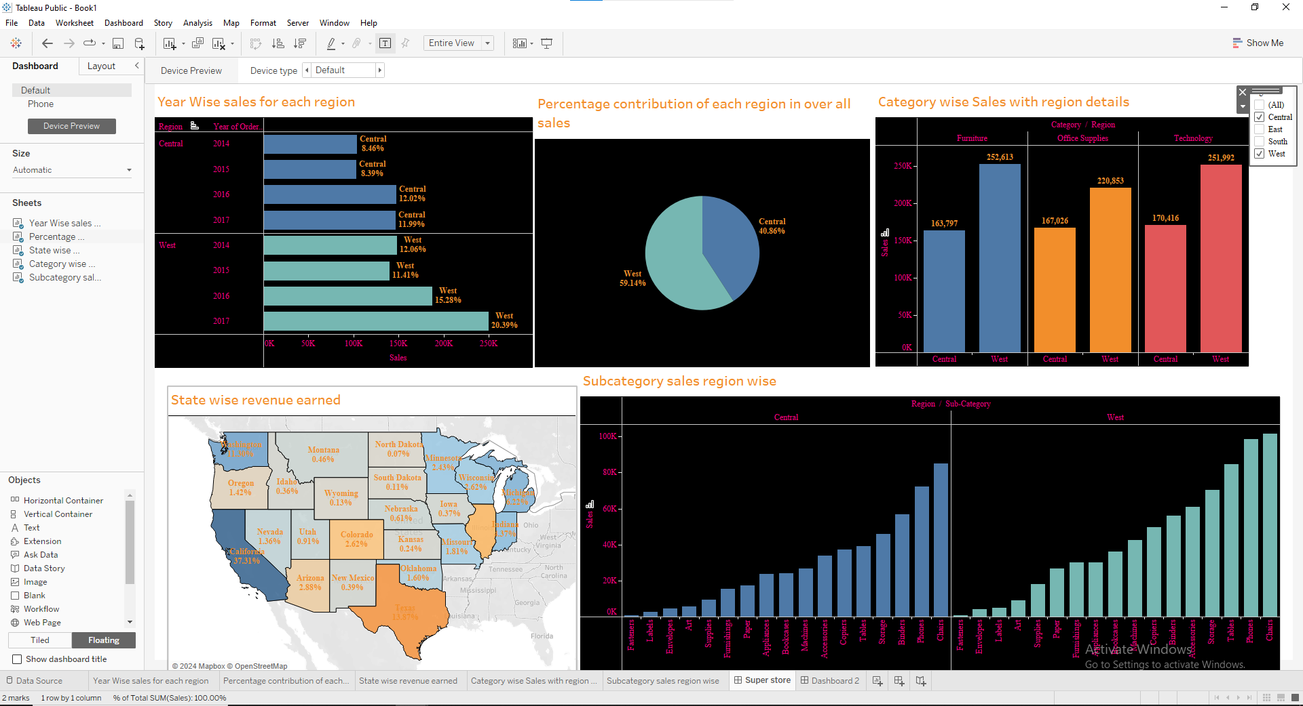

**Create an Interactive dashboard for a sample superstore Profit summary which should present: • Month profit earned in each category, Min & Max profit should be displayed. • Category-wise Profit with region details. • Subcategory-wise profit (use waterfall chart). • Segment-wise profit percentage. • Percentage contribution of each region in overall profit. • State-wise profit earned (Word Map) The dashboard should be interactive based on Category**.

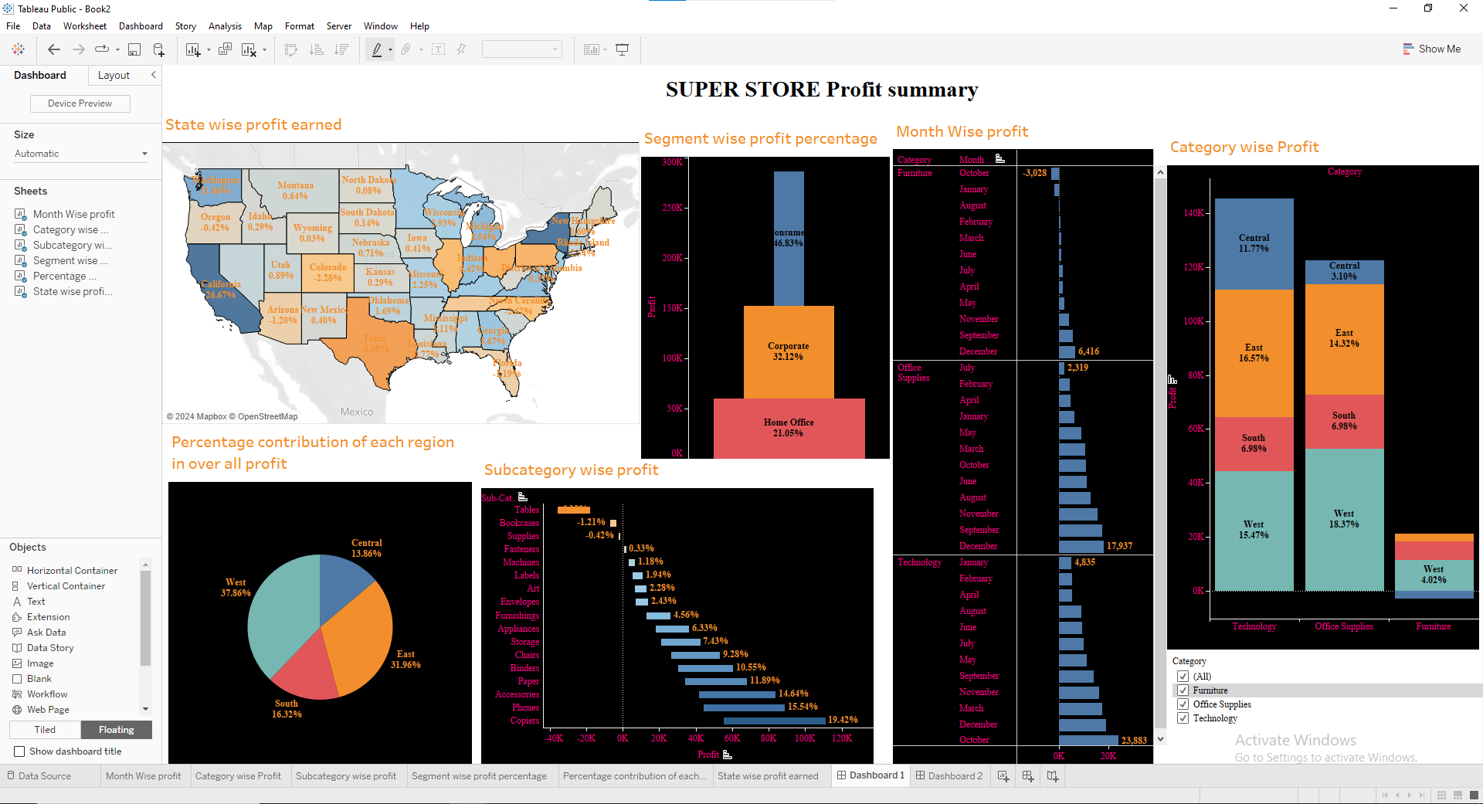

**After applying filter**

